Division of Graduate Studies and Research
UB Board of Trustees
May 14, 2010

Report for Academic Year 2009-2010

This report is a comprehensive overview of the developments achieved through the Division of Graduate Studies and Research for the current academic year.

Goal: Develop into a regional research center of excellence in the development of emerging technologies, applied industry-oriented R&D, and health sciences and inter-disciplinary research

Strategy 1: Strengthen resources and infrastructure to support and facilitate research.

Graduate Student Recruitment/Marketing/Scholarship Program
A new marketing/scholarship program was launched in the spring to recruit international and domestic graduate students. The Division of Graduate Studies and Research developed and managed the initiative jointly with UB Admissions and University Relations. A scholarship information poster and four explanatory letters were mailed to four (4) targeted populations: (1) provosts, deans and/or chairs of 1,060 U.S. universities and colleges with undergraduate business, engineering, liberal arts and sciences, industrial relations, and/or peace and conflict resolution studies, that did not have an M.S. or Ph.D in engineering or MBA programs; (2) representatives at 200 U.S. Education Foundation Advisor Centers located in 53 UB-priority countries; (3) 300 agents and consultants identified by UB’s international admissions office; and (4) administrators, deans, chairs and/or international study abroad directors at 1,152 international universities located in 51 countries that were identified by UB with the help of international students who were from these countries or were familiar with these nations’ educations systems, university rankings and other attributes.

UB representatives travelled to India this spring, where UB’s key consultants and the US Education Foundation Advisory Centers visited were very excited about the scholarship program.

Scholarship information also was e-mailed with both a poster and letter attachments to 3,563 domestic and international alumni requesting their help in spreading the word to universities located in their communities as follows: School of Engineering (1,513), School of Business (1,212), alumni of math and science programs (366), and International College (272).

Program highlights:
- Students applying to the MBA Program, Global Development and Peace Program, or any program in our School of Engineering (MS in Mechanical, Electrical, Biomedical, Computer Science, Computer Engineering or Technology Management as well as the Ph.D degree) are eligible for this award.
- All applicants will automatically be considered for a scholarship when they send in the University of Bridgeport application and all admissions materials. No additional form is needed.
- Students who wish to be considered for a scholarship must submit a GRE or GMAT score.
- There are three award amounts: $3,000, $4,000 and $5,000 per year. This award is based on the student’s academic achievement and test scores.
- The scholarship will be for the new domestic or international graduate student’s first year of study.
- All graduate students with a scholarship must take 9 credits per semester.

Agreements with International Universities and Business Development
Over the past two years, UB has developed a Memorandum of Understanding with SENAC (Centro Universitário Senac, a large university in Brazil Centro), which has resulted in a number of mutually beneficial specific agreements as follows:
- UB and Senac have signed an agreement to offer a M.S. in Technology Management degree. Senac will teach several courses in Brazil and the students would then come to UB to complete the degree.
- A three-week “summer abroad” program for international undergraduate students from Senac has been developed and will be offered at UB starting this summer, contingent upon a minimum enrollment of 10 students, in which a non-credit educational and cultural program will be offered in the hope of attracting new graduate students to UB. This agreement will be signed within the next two weeks. This could become a model for other undergraduate summer abroad programs at UB for international students from other countries such as Egypt, China, etc.
- The School of Engineering is working on a proposed agreement to offer a “2+2” program leading to a B.S. in Computer Science or a B.S. in Computer Engineering. Two years of courses would be offered at Senac and the other two offered at UB.
- UB’s School of Business has submitted an MBA agreement to Senac.
- Senac and UB are also discussing the development and delivery of a five (5) day Executive Management Seminar for Brazilian Senior Managers to be offered both in Brazil and at UB in a November time frame.

Four MOU-type agreements have been signed with Chinese institutions. We also expect to sign an MOU with the University of Salerno in Salerno, Italy within the next two to three weeks.

A “generic” agreement has been approved by UB’s School of Engineering to be entered into with any international university, to teach three courses in the home country, with the remainder of courses to be taught at UB ( with some delivered through Distance Learning), with a UB degree earned.
UB is in communication with universities in India, Egypt, Israel, Turkey, China, and Brazil to develop joint agreements that are mutually beneficial. The graduate scholarship program identified 53 countries within which UB might want to approach various institutions to discuss the possibility of developing an agreement. A database of the names and positions of key administrators has already been established.

Graduate Assistantships
The funds spent on graduate assistants for the Fall 2009 and Spring 2010 semesters were $1,377,070, compared with $1,042,530 for Academic Year 2008-2009. Approximately 164 graduate students were awarded a graduate assistantship for the Fall 2009 semester, followed by approximately 151 students in the Spring 2010 semester.

Federally Negotiated Indirect Rate
UB has established a federal rate agreement for indirect and fringe benefits rates with the U.S. Department of Health and Human Services’ Division of Cost Allocation effective 7/1/2009 to 6/30/2013. The on-campus indirect rate is 49.4% and the fringe benefits rate for full-time employees is 25.5%. These rates are applied in most federal research grant applications.

Graduate Studies and Research Website Update
The current website (www.bridgeport.edu/gsr) will be redesigned and the content distributed between the external UB website and the new, internal portal site, during the summer. The portal will provide a location for many documents that are useful and necessary to faculty researchers but, for privacy, have not been posted on the current site, which is open to the public. The result will not only streamline and automate a manual process (policies and forms distribution), but the portal will allow for the development of virtual user groups for researchers for short-term grant application development and long-term discussion and dissemination groups.

Councils
The Faculty Research Council and Graduate Council launched faculty newsletters this year (Appendix A). In addition, the Graduate Council’s current duties of review and recommendation for proposed interdisciplinary graduate programs were expanded to review and recommendation of all proposed graduate programs.

Development and Alumni Activities
A targeted e-mail was sent to all School of Engineering alumni to request funding to support the growth of the school. A total of 1,636 e-mails were sent to 252 domestic and 1,384 international alumni. International alumni visited the website 21 times and seven domestic alumni visited seven times, resulting in two donations that totaled $150 so far.

Strategy 2: Strengthen collaborations with industry within the areas of sponsored projects.

CTech IncUBator
The agreement to establish a partnership between Connecticut Innovations and UB to found an incubator was signed on March 4, 2010. As noted in Governor Rell’s April 27, 2010 press release (Appendix B), this is the first and only university-based incubator for high-tech start-ups located in Fairfield County. During the planning and development process, a number of university-based and private sector incubator directors were visited or talked to by phone to identify best practices for implementation in UB’s incubator. Various CTech IncUBator documents have been completed to date such as: Tenant Lease Form and Pro-Bono Sponsorship Form. Marketing materials and a web site are being developed.

The incubator has been developed with the following objectives:
- Nurture and facilitate growth of new businesses and jobs in high technology and technology ventures.
- Foster and stimulate economic development and job creation in Greater Bridgeport, Fairfield County, and the State of Connecticut.
- Support and enable the growth and commercialization of UB’s applied research and intellectual property initiatives (e.g., U.S. Army Hybrid Projectile Design initiative – part of a $2.4 million grant; NSF Smart Browsing Systems for Endoscopy videos – $147,655 pending grant).
- Build synergy and collaboration among industry, education, and government sectors.
- Become self-sustaining: generate revenues through rent income, IP royalties, license fees, sponsor contributions, grants, donations, etc.
- Leverage educational, faculty, student interns and facility resources for career and economic development.

A number of companies have expressed interest and are considering occupancy. An advisory board is currently being established, as well as a list of potential pro bono professional service providers. Governor Rell’s press release was e-mailed to 7,800 alumni and friends. The publicity has generated significant interest and inquiries, including responses from 10 UB alumni who have volunteered to help in some way.

UB’s Executive Board was updated on the CTech IncUBator initiative at the April 2, 2010 meeting. A request was made to the Board members for any type of assistance with launching the incubator.

The incubator will be housed in 250 Myrtle Avenue, which currently is being prepared with an anticipated occupancy of June/July. The official opening is targeted for September. Connecticut Innovations is purchasing the furniture, printer/copier, and a large screen monitor. CTech IncUBator includes six offices, some of which may be shared; the facility can handle up to 30 people.

UB Industry Advisory Boards (IABs)
This year, a formal guideline was developed, finalized, and approved by the respective Deans and the VP of the Division of Graduate Studies and Research that outlines the mission, structure, roles, responsibilities and expectations of all industry advisory boards for graduate programs at UB (Appendix C). While various advisory groups have existed in the past, the new IABs will be focused to provide very specific types of support to the various schools and colleges with graduate enrollments, as well as the groups and departments within the Division of Graduate Studies and Research. The roles and responsibilities of each IAB are as follows:
- Provide external and objective advice and counsel to the Graduate Studies and Research Division and its schools on its programs and initiatives from an industry and market perspective.
- Help shape the direction of education by suggesting ideas for new courses, degree and certificate programs and interdisciplinary initiatives.
- Support institutional and sponsored research in the business, engineering and education fields through grants, contributions, joint collaboration and other services.
- Hire student interns, co-ops and graduates.
- Increase the visibility and image of UB and promote UB to potential students, employers, government agencies, business and industry.
- Contribute financial support, fundraising and/or in kind services such as equipment/hardware/software donations and time allocated to UB activities.
- Champion and support programs to attract potential donors, partners and friends.
- Serve as a liaison between UB and his/her organization by communicating developments at the university.
- Give guest lectures and presentations, participate in colloquia and/or consider becoming an executive-in-residence.

IABs have been newly established for the Division of Graduate Studies and Research and the School of Engineering. The Graduate Studies and Research IAB is comprised of 31 individuals who represent companies and organizations including GE, Covanta Energy, Santa Energy, Pitney Bowes, Connecticut Innovations, Warnaco, Terex, TD Bank, Discovery Museum, Newton Savings Bank, The Workplace Inc., Connecticut Center for Advanced Technology, Inc., 3M Purification Inc., Oracle and others. The School of Engineering IAB is comprised of 16 companies and their representatives, including IBM, Oracle, 3M Purification Inc., Lacey Manufacturing Co., PerkinElmer Life and Analytical Sciences, CT Venture Group, Inc. and others. IABs for the School of Business and School of Education are under development, to be formed by the dean of each school.

The Division of Graduate Studies and Research and School of Engineering’s IABs held a joint meeting on April 27, which was well attended. One of the meeting’s outcomes was the establishment of a Google group, which has already been joined by more than 25 people. The IAB will form special interest groups based on topics of mutual interest.

Internships and Co-ops
The number of co-ops and internships was adversely affected by the U.S. economic crisis during 2009. The 456 in 2008 was greatly reduced in 2009 to 185. For the Spring 2010 semester, 56 UB students secured a co-op or internship. During the Fall 2009 semester, 73 companies hired UB students for internships and co-ops. This number dropped to 54 companies in the Spring 2010 semester (Appendix D).

Internships and Co-op Website
The Graduate Studies and Research website hosts a site at which employers, prospective employers, students, prospective students, and the general public can view a list of the companies at which UB students have worked or are working.

Industry Cooperative Education and Internships Program Guidelines
There is much confusion among U.S. employers regarding the hiring of international students, what STEM means, the various visa classifications, etc. To help prospective employers of international student graduates from UB, an updated “Industry Cooperative Education and Internships Program Guidelines,” was developed by the Offices of International Student Affairs, Admissions, Business Development and Outreach, Career Services and the Schools of Engineering and Business.

Draft guidelines have been prepared and reviewed. The guidelines will be finalized in May and two versions will be made available to employers and other interested constituents – a hard copy booklet and a web version on the UB web site.

Strategy 3: Strengthen faculty training programs to increase the participation of faculty in sponsored research projects.

Faculty Grants and Contracts
UB faculty members have been awarded a number of pieces of equipment through the U.S. Department of Energy’s Energy Related Laboratory Equipment (ERLE) grant program. The original acquisition cost of equipment awarded during the 2008-2009 Academic Year was $711,190 and as of May 1, 2010, the original acquisition cost of equipment awarded during the 2009-2010 Academic Year was $193,198 (Appendix E). These instruments are being used to equip the Nanomaterials & Nanobiomaterials Engineering Laboratory, and the Renewable Energy Research Laboratory that are under development at UB. Two grant applications were recently submitted to the National Science Foundation’s Major Research Instrumentation program for funding to acquire additional pieces of equipment for these laboratories.

In early February 2010, the School of Engineering was informed that a $2.4 million grant had been awarded to a consortium, of which UB and the University of Hartford played the leading role, to develop the next-generation projectiles for the U.S. Army. An interim grant of $30,000 through Imperial Machines Co., Inc., has been awarded to conduct initial work on the major project until the appropriations funding is made available, expected for July 2010.

A proposed study, “NMR Detection of Graphene Nanoribbons”, was recently selected for a P30 grant from Yale University School of Medicine’s Magnetic Resonance Research Center. The P30 grant will cover all costs associated with these NMR scans, reagents used for sample preparation, and effort on the part of scientists, technicians, and/or engineers. The pilot study will provide data critical to the eventual application for funding to the National Institutes of Health. The application was selected through an extremely competitive process.

UB joined a national consortium of universities, headed by the University of Minnesota, as part of a successful grant application submitted to the U.S. Department of Energy’s Strategic Training and Education in Power Systems program. The project, “A Nationwide Consortium of Universities to Revitalize Electric Power Engineering Education by State-of-the-Art Laboratories”, will facilitate the implementation of laboratories to create a new educational framework in power engineering that will transform undergraduate and graduate education and research in the areas of renewable energy and meet the challenges of making the grid cleaner, smarter, and more reliable. UB is one of 64 collaborating universities, and will be represented by two UB faculty members from the School of Engineering.

Currently, nine research applications are pending, for a total $1,426,440. (A list of awarded and pending are in Appendix F.)

UB has also contracted with a grant writing company to secure grant writers who are working with UB faculty to write four separate applications to the National Science Foundation’s Transforming Undergraduate Education in Science, Technology, Engineering and Mathematics (TUES) program. Each applicant is permitted to request up to $200,000 for a two or three-year project.

Once again, over $8 million of licenses and software was contributed for research and student use throughout Academic Year 2009-2010 by 19 companies (Appendix G).

Student Grants
An engineering graduate student has been awarded a $5,000 grant by the Connecticut Space Grant Consortium UTC Summer Internship. The student will work at a ten-week internship with Otis Elevator Company in the electrical and software standards group.

Undergraduate engineering students have been awarded a $4,500 grant by the Connecticut Space Grant Consortium to build a lunar excavator that will be entered into the NASA Lunabotics Mining Competition at Kennedy Space Center in Florida from May 25-28.

Faculty Expertise Searchable Database
UB faculty expertise and research interests can be searched by name, topics, areas of interest, or other terms, and is available to the UB community and the general public on the UB Graduate Studies and Research website. This is particularly useful for UB as research interests become more interdisciplinary, and useful to researchers at other institutions, as they seek for collaborative partners.

Faculty Scholarly Works
Eight journal articles have already been published by UB faculty in 2010, with 42 having been published in 2009 and 29 in 2008. In 2009, 87 conference papers were published by UB faculty (Appendix H). The Office of Sponsored Research provides proofreading services to support faculty publication efforts.

UB Faculty Works on UB Library Website
More than 400 digital copies of publications have been submitted by UB faculty members to the UB library. With the launch of the IT initiatives, the publications will be incorporated into a searchable database for use by UB students, faculty, and community.

Academic Program Development
The M.S. in Biomedical Engineering program has had a successful first year, with a current enrollment of more than 40 students.

A number of courses have been developed and are being offered or will be offered in nanotechnology and renewable energy to School of Engineering graduate students. Nanotechnology courses include: Introduction to Nanotechnology, Fundamental Analysis of Nanomaterials, Nanofabrication with Soft Materials, Polymer Nanocomposites, Biomedical Materials and Engineering, and Tissue Engineering. Renewal energy courses include: Fuel Cells, Sustainable Energy, and Sustainable Energy Laboratory.

The School of Engineering publishes a periodic newsletter to alumni and friends. The Summer 2010 issue contains considerable information on faculty and student achievements and new programs.

PowerPoint Presentation
A copy of the PowerPoint presentation created to accompany this report is attached (Appendix I).

Appendix A

Faculty Research Council Newsletter

Graduate Council Newsletter
UB Faculty Research Council Newsletter
March 1, 2010

News You Can Use

Graduate Studies and Research Website
There is a wealth of information and important links on the UB Graduate Studies and Research Website (including a link to the Faculty Research Council site). This can be accessed through Academics or Quicklinks on the UB website or by inserting the following into your browser: https://www.bridgeport.edu/gsr .

Proofreading/Editing Service
A freelance proofreader is available to proofread and provide edits for selected grant applications and articles for publication, as approved by Dr. Sobh. If you wish to use this person’s services, please contact Christine Hempowicz in the Office of Sponsored Research (x4973 or chemp@bridgeport.edu). Be advised that you will need to allow up to two weeks for this service, so plan accordingly.

Grant Writing Service
The Office of Sponsored Research has identified some independent grant writers that may be able to work with a principal investigator to write a less research-intensive grant such as for the National Science Foundation’s Transforming Undergraduate Education in Science, Technology, Engineering, and Mathematics grant. Please contact Christine Hempowicz (x4973 or chemp@bridgeport.edu) for more information.

Institutional Review Board
UB’s IRB has been registered with the Office of Human Subjects Protection, U.S. Department of Health and Human Services. All research projects utilizing human subjects must submit the appropriate documents to the IRB. Further information can be found at https://www.bridgeport.edu/IRB.

High Tech Incubator
UB is in the final stages of implementing a high tech incubator (in this case the incubator is used for high tech projects not microbes!), housed at 250 Myrtle Avenue. UB is partnering with CT Innovations for this initiative. Three small high tech companies have already been identified to move in, once the contract has been signed with CT Innovations and the facilities are ready. Faculty may be interested in working with these companies and as this proceeds further announcements will be made. Stay tuned!

UB Library Repository for Faculty Publications
Full time faculty and adjuncts are encouraged to send your published peer reviewed journal articles, abstracts from conferences, book chapters, and letters to the editors utilizing the following procedure:

- Send a separate e-mail with attachment for each publication to Deborah Dulepski at ddulepsk@bridgeport.edu and CC it to research@bridgeport.edu

- Each e-mail must include the following information:
  - Your Name
  - Attached publication as a PDF file
  - The reference information on the article
  - The name of the publisher

Repositories for Not-yet-published Documents on Research Projects at UB
The Faculty Research Council will be creating a virtual repository on the UB website where working papers and technical reports could be uploaded.

Responsible Conduct of Research (RCR)
A compliance requirement is being implemented by National Science Foundation, effective January 4, 2010. NSF will require that, at the time of proposal submission to NSF, a proposing institution’s Authorized Organizational Representative certify that the institution has a plan to provide appropriate training and oversight in the responsible and ethical conduct of research to undergraduates, graduate students, and postdoctoral researchers who will be supported by NSF to conduct research. UB has registered with the Responsible Conduct of Research Interactive Tutorials (www.responsibleresearch.org), in part to fulfill this requirement. Please contact Christine Hempowicz at chemp@bridgeport.edu for further information.

Recent Publications, Presentations, Research Grant Awards

February Conference and Workshop Presentations
What | College Art Association (CAA) 98th Annual Conference
Website | www.collegeart.org
When | February 10-13, 2010
Where | Chicago, IL
Faculty | Emily Larned
Department | Graphic Design
Description | Presentation of artwork for a panel entitled “Hypotechnology: Artists Remix the Anachronistic and Obsolete with the Present”
What | International Studies Association Annual Convention
Website | www.isanet.org/neworleans2010/
When | February 17-20, 2010
Where | New Orleans, LA
Faculty | Dave Benjamin
Department | International College
Description | Paper on "Human Security and Prevention of State Collapse"; Panel Chair and Discussant, "Human Security and the Challenges of Children in War"; Panel Discussant, "International Law and Human Security; Panel Chair, "Authorized and Unauthorized Humanitarian Interventions and the Construction of Peace"

What | Midwest Finance Association (MFA) Annual Meeting
Website | www.midwestfinance.org
When | February 24-27, 2010
Where | Las Vegas, NV
Faculty | James Sagner
Department | School of Business
Description | “Bank Transparency: Cost of Capital and Credit Returns Issues,” and Discussant
What | Midwest Finance Association Annual Meeting
Website | www.mfa-2010.com
When | February 24-27, 2010
Where | Las Vegas, NV
Faculty | James Sagner
Department | School of Business
Description | Presented two papers, "Bank Transparency: Cost of Capital and Credit Return Issues", and "Opaqueness and Bank Risk Taking"

Research Grant Awards
Dr. Tarek Sobh, Vice President for Graduate Studies and Research and Dean of the School of Engineering learned recently that a $2.4 million federal grant has been awarded to a consortium, of which UB is a primary member, to develop drones for the U.S. Army. The application was developed primarily by Dr. Sobh and Dr. Lou Manzione, Dean of the College of Engineering, Technology and Architecture at the University of Hartford, along with the University of Connecticut and the Connecticut Center for Advanced Technology. The following UB faculty are involved in the project: Dr. Sobh (PI), Dr. Khaled Elleithy, Dr. Jeongkyu Lee, Dr. Prabir Patra, Dr. Xingguo Xiong, and Dr. Hassan Bajwa. Several UB engineering students will work with the project as well. Funding for the 18-month project should be available starting July 2010. Read more about this exciting opportunity below under “Faculty Research Spotlight.”

Research Grant Information of Interest to UB Faculty

SBIR and STTR
With the start up of the UB High Tech Incubator, faculty may be interested in collaborating on Small Business Innovation Research (SBIR) and Small Business Technology Transfer (STTR) grants. A number of federal agencies award funding to small businesses for research projects to with which faculty can be involved. For more information, read the following description from the official federal SBIR website (http://www.sbir.gov ):

ABOUT SBIR AND STTR PROGRAMS
The U.S. Small Business Administration (SBA) Office of Technology administers the Small Business Innovation Research (SBIR) Program and the Small Business Technology Transfer (STTR) Program. Through these two competitive programs, SBA ensures that the nation's small, high-tech, innovative businesses are a significant part of the federal government's research and development efforts. Eleven federal departments participate in the SBIR program; five departments participate in the STTR program awarding $2 billion to small high-tech businesses. The U.S National Science Foundation administers the SBIR.GOV site on behalf of the federal government.

NSF Major Research Instrumentation Program (MRI)

Synopsis from the Program Solicitation
The Major Research Instrumentation Program (MRI) serves to increase access to shared scientific and engineering instruments for research and research training in our Nation’s institutions of higher education, museum, science centers, and not-for-profit organizations. This program especially seeks to improve the quality and expand the scope of research and research training in science and engineering, by providing shared instrumentation that fosters the integration of research and education in research-intensive learning environments. Development and acquisition of research instrumentation for shared inter- and/or intra-organizational use are encouraged, as are the development efforts that leverage the strengths of private sector partners to build instrument development capacity at academic institutions.

Instrument acquisition or development proposals that request funds for NSF in the range $100,000 - $4 million will be accepted. Proposals that request funds from NSF less than $100,000 will also be accepted from all eligible organizations for the disciplines of social, behavioral and economic sciences and from non-Ph.D.-granting institutions of higher education for all NSF-supported disciplines.

Full Proposal Deadline: April 21, 2010.

MRI Website: http://www.nsf.gov/funding/pgm_summ.jsp?pims_id=5260&org=NSF&sel_org=NSF&from=fund

NOTE: NSF limits the number of applications that can be submitted by an organization. Contact Christine Hempowicz at x4973 or by e-mail at chemp@bridgeport.edu immediately if you are interested in applying for a MRI grant.

NSF Transforming Undergraduate Education in Science, Technology, Engineering, and Mathematics (TUES) [Formerly the Course Curriculum and Laboratory Improvements Program (CCLI)]

Synopsis from the Program Solicitation
The Transforming Undergraduate Education in Science, Technology, Engineering, and Mathematics (TUES) program seeks to improve the quality of science, technology, engineering, and mathematics (STEM) education for all undergraduate students. This solicitation especially encourages projects that have the potential to transform undergraduate STEM education, for example, by bringing about widespread adoption of classroom practices that embody understanding of how students learn most effectively. Thus transferability and dissemination are critical aspects for projects developing instructional materials and methods and should be considered throughout the project’s lifetime.

The program supports efforts to create, adapt, and disseminate new learning materials and teaching strategies to reflect advances both in STEM disciplines and in what is known about teaching and learning. It funds projects that develop faculty expertise, implement educational innovations, assess learning and evaluate innovations, prepare K-12 teachers, or conduct research on STEM teaching and learning. The program supports projects representing different stages of development, from small, exploratory investigations to large, comprehensive projects.

Full Proposal Deadline: May 26, 2010.

TUES Website: http://www.nsf.gov/funding/pgm_summ.jsp?pims_id=5741

Contact Christine Hempowicz at x4973 or by e-mail at chemp@bridgeport.edu immediately if you are interested in applying for a TUES grant.

Faculty Research Spotlight

What flies through the air at 150 miles per hour, transmits video images, and is roughly the size of a soda can? If you’re not sure, ask Tarek Sobh, the Dean of UB’s School of Engineering.

The U.S. Army has awarded $2.4 million to the Applied Nanotechnology Consortium, a group comprised of UB, the University of Hartford, and UConn, and area organizations and industry. Dr. Sobh is heading up the UB engineering research team, which includes Drs. Elleithy, Lee, Patra, Xiong, and Bajwa. He envisions that the 18-month research project will be one of many through the continued development of the Consortium. This comes on the wings of an earlier award for preliminary research, part of which was conducted at UB by Dr. Sobh and select faculty.

The Consortium is charged with the design and creation of an unmanned device that will carry a video camera over large distances in real time. The aerial drone will provide a soldier with a means of “seeing” a limited range of landscape that would otherwise be hidden from view. The device will most likely be fired from a tube, similar to those used in mortar fire. The images are transmitted back in real time, so that the viewer can see what the device ‘sees’ during it’s approximately 40 second journey.

In addition to aiding soldiers oversees, the project is also generating a lot of great press for UB. Please see both features in the Connecticut Post.

From February 5th: UB helps Army create flying soda can
http://www.ctpost.com/default/article/UB-helps-Army-create-flying-soda-can-353459.php

From February 9th: Another sign of vitality for UB
http://www.ctpost.com/default/article/Another-sign-of-vitality-for-UB-357837.php

The Faculty Research Council congratulates Dr. Sobh and fellow faculty for their work with the Applied Nanotechnology Consortium. And remember, if you see a soda can whizzing overhead on campus, don’t forget to smile and say, “Cheese.” You may end up on UB’s Funniest Campus Videos!

University of Bridgeport Graduate Council
Newsletter
April 6, 2010

Message to UB Faculty and Staff
The Graduate Council (GC), which now serves as a committee of the Faculty Senate, is excited to announce the introduction of a regular newsletter that will keep you informed of our various efforts. We would like to keep our group accessible and relevant, so please feel free to participate by making suggestions, either related to content or delivery to Art McAdams at amcadams@bridgeport.edu – thanks.

The Council was formed for the 2008-2009 academic year, under the leadership of Dr. Tarek Sobh, Vice President for Graduate Studies and Research, to approve mechanisms and policies for interdisciplinary graduate curricula, course and program management. Responsibilities have been expanded to include review and recommendation of all proposed graduate programs. In addition, we will seek ways to leverage and share best practices across colleges and schools with graduate programs at UB.

As a reminder, please be sure to inform the GC of any changes to your graduate programs. Should you have an upcoming change – or if you would like to discuss a proposal – we will ask you to join us at our monthly meeting. We will do our best to make productive use of your time. In addition to examining the program and looking for internal synergies, we will be happy to assist, to the extent that you would like, with marketing ideas, execution logistics, etc.

Our upcoming issues of the GC newsletter will also include information on the interdisciplinary graduate programs that are in place at UB, as well as other graduate programs and plans for future programming. In addition, we will compile a list of resources available to support faculty publication and graduate student support.

In the near future, we will be compiling a list of all graduate programs at UB and sharing them with you as a way to build a base for further discussion. We also plan on populating our content in electronic format. We will keep you posted on the details as we progress.
Thanks again for your interest and support and please don’t hesitate to contact us with comments and suggestions. The newsletter is being compiled by Art McAdams, Wendy Garcia, and Christine Hempowicz.

Graduate Council Website
Please take a minute to look through the Graduate Council (now GCC) website. https://www.bridgeport.edu/pages/5485.asp that is part of the Graduate Studies and Research website, www.bridgeport.edu/gsr.

GC Members List
Arthur C. McAdams III, Ph.D. Chair School of Business
Wendy Garcia, M.S.Ed. Fones School of Dental Hygiene
Barry Kendler, Ph.D. Nutrition Institute
Neal Lewis, Ph.D. School of Engineering
Mark Mattie, Ph.D. College of Naturopathic Medicine
Joseph Morley, D.C. College of Chiropractic
Lori Noto, Ph.D. School of Education and Human Resources
Chunjuan Nancy Wei, Ph.D. International College

Minutes from March 2, 2010 Meeting
Expanded Role of the Graduate Council
Provost Spitzer has recommended that the Graduate Council serve as the “Graduate Council Committee” for the Faculty Senate. A draft description of membership and duties was distributed to those present. The current duties of review and recommendation for proposed interdisciplinary graduate programs would be expanded to review and recommendation of all proposed graduate programs. Such recommendations would be forwarded to the Faculty Senate. The Graduate Council members who were present approved the Provost’s proposal.

Election of Graduate Council Chair
Art McAdams was nominated and unanimously approved to be chair of the Graduate Council.

Graduate Resource Center
This is a reminder to inform all UB faculty who teach graduate courses that academic writing tools are available to support graduate students on the Graduate Studies and Research website under the section, “For Potential and Current Students”, which can be found at: www.bridgeport.edu/gsr. All UB faculty will be informed as other services are added.

Proofreading Services
The service that is available to faculty is being extended to support significant publications for national or international scholarly journals in which a faculty member is involved, but students are also authors. Contact Christine Hempowicz at x4973 or chemp@bridgeport.edu for more information.

Graduate Scholarship Program
A merit-based scholarship program for applicants to some UB graduate programs was developed last year and implemented this year for the Schools of Business and Engineering, and the International College. Other UB schools/colleges with graduate programs may want to conduct a cost benefits analysis to determine if they could implement such a merit-based scholarship in order to attract additional, academically excellent students into their programs. See www.bridgeport.edu/pages/6003.asp.

Graduate Council Newsletter
The Graduate Council will launch a newsletter targeted towards UB faculty in the near future. Council Chair Art McAdams, member Wendy Garcia, and Christine Hempowicz will work together on it.

Appendix B

Governor Rell’s April 27, 2010 Press Release

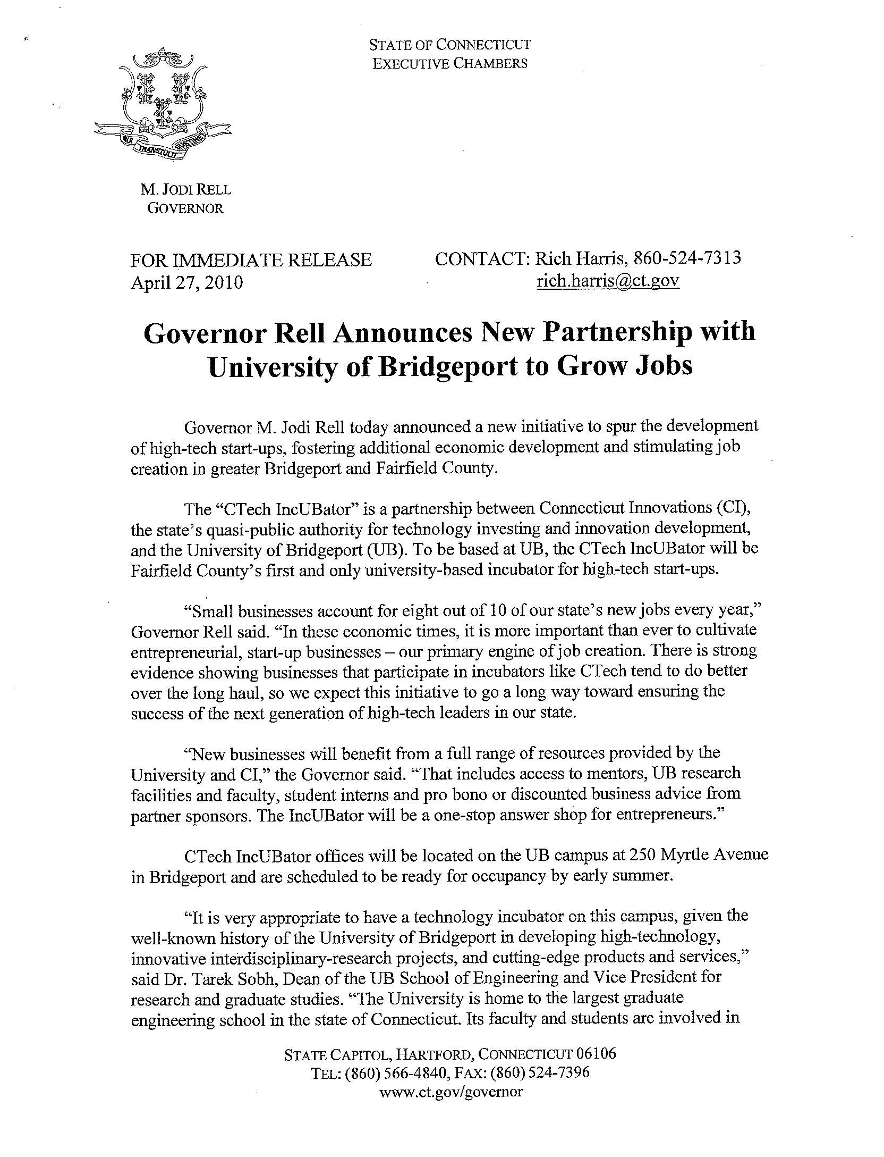
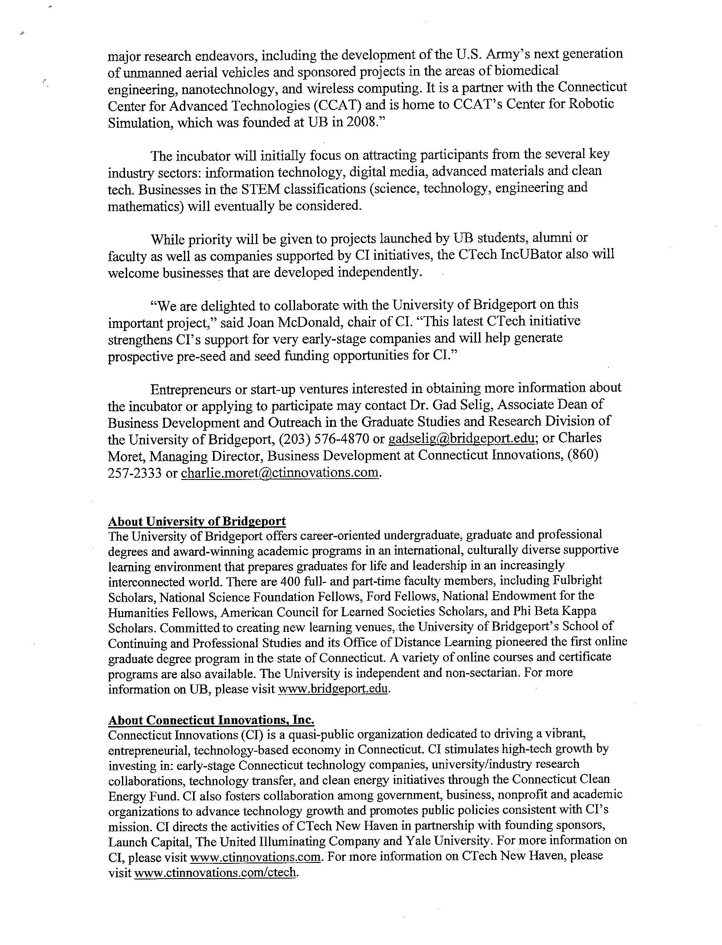

Appendix C

Industrial Advisory Board Guidelines

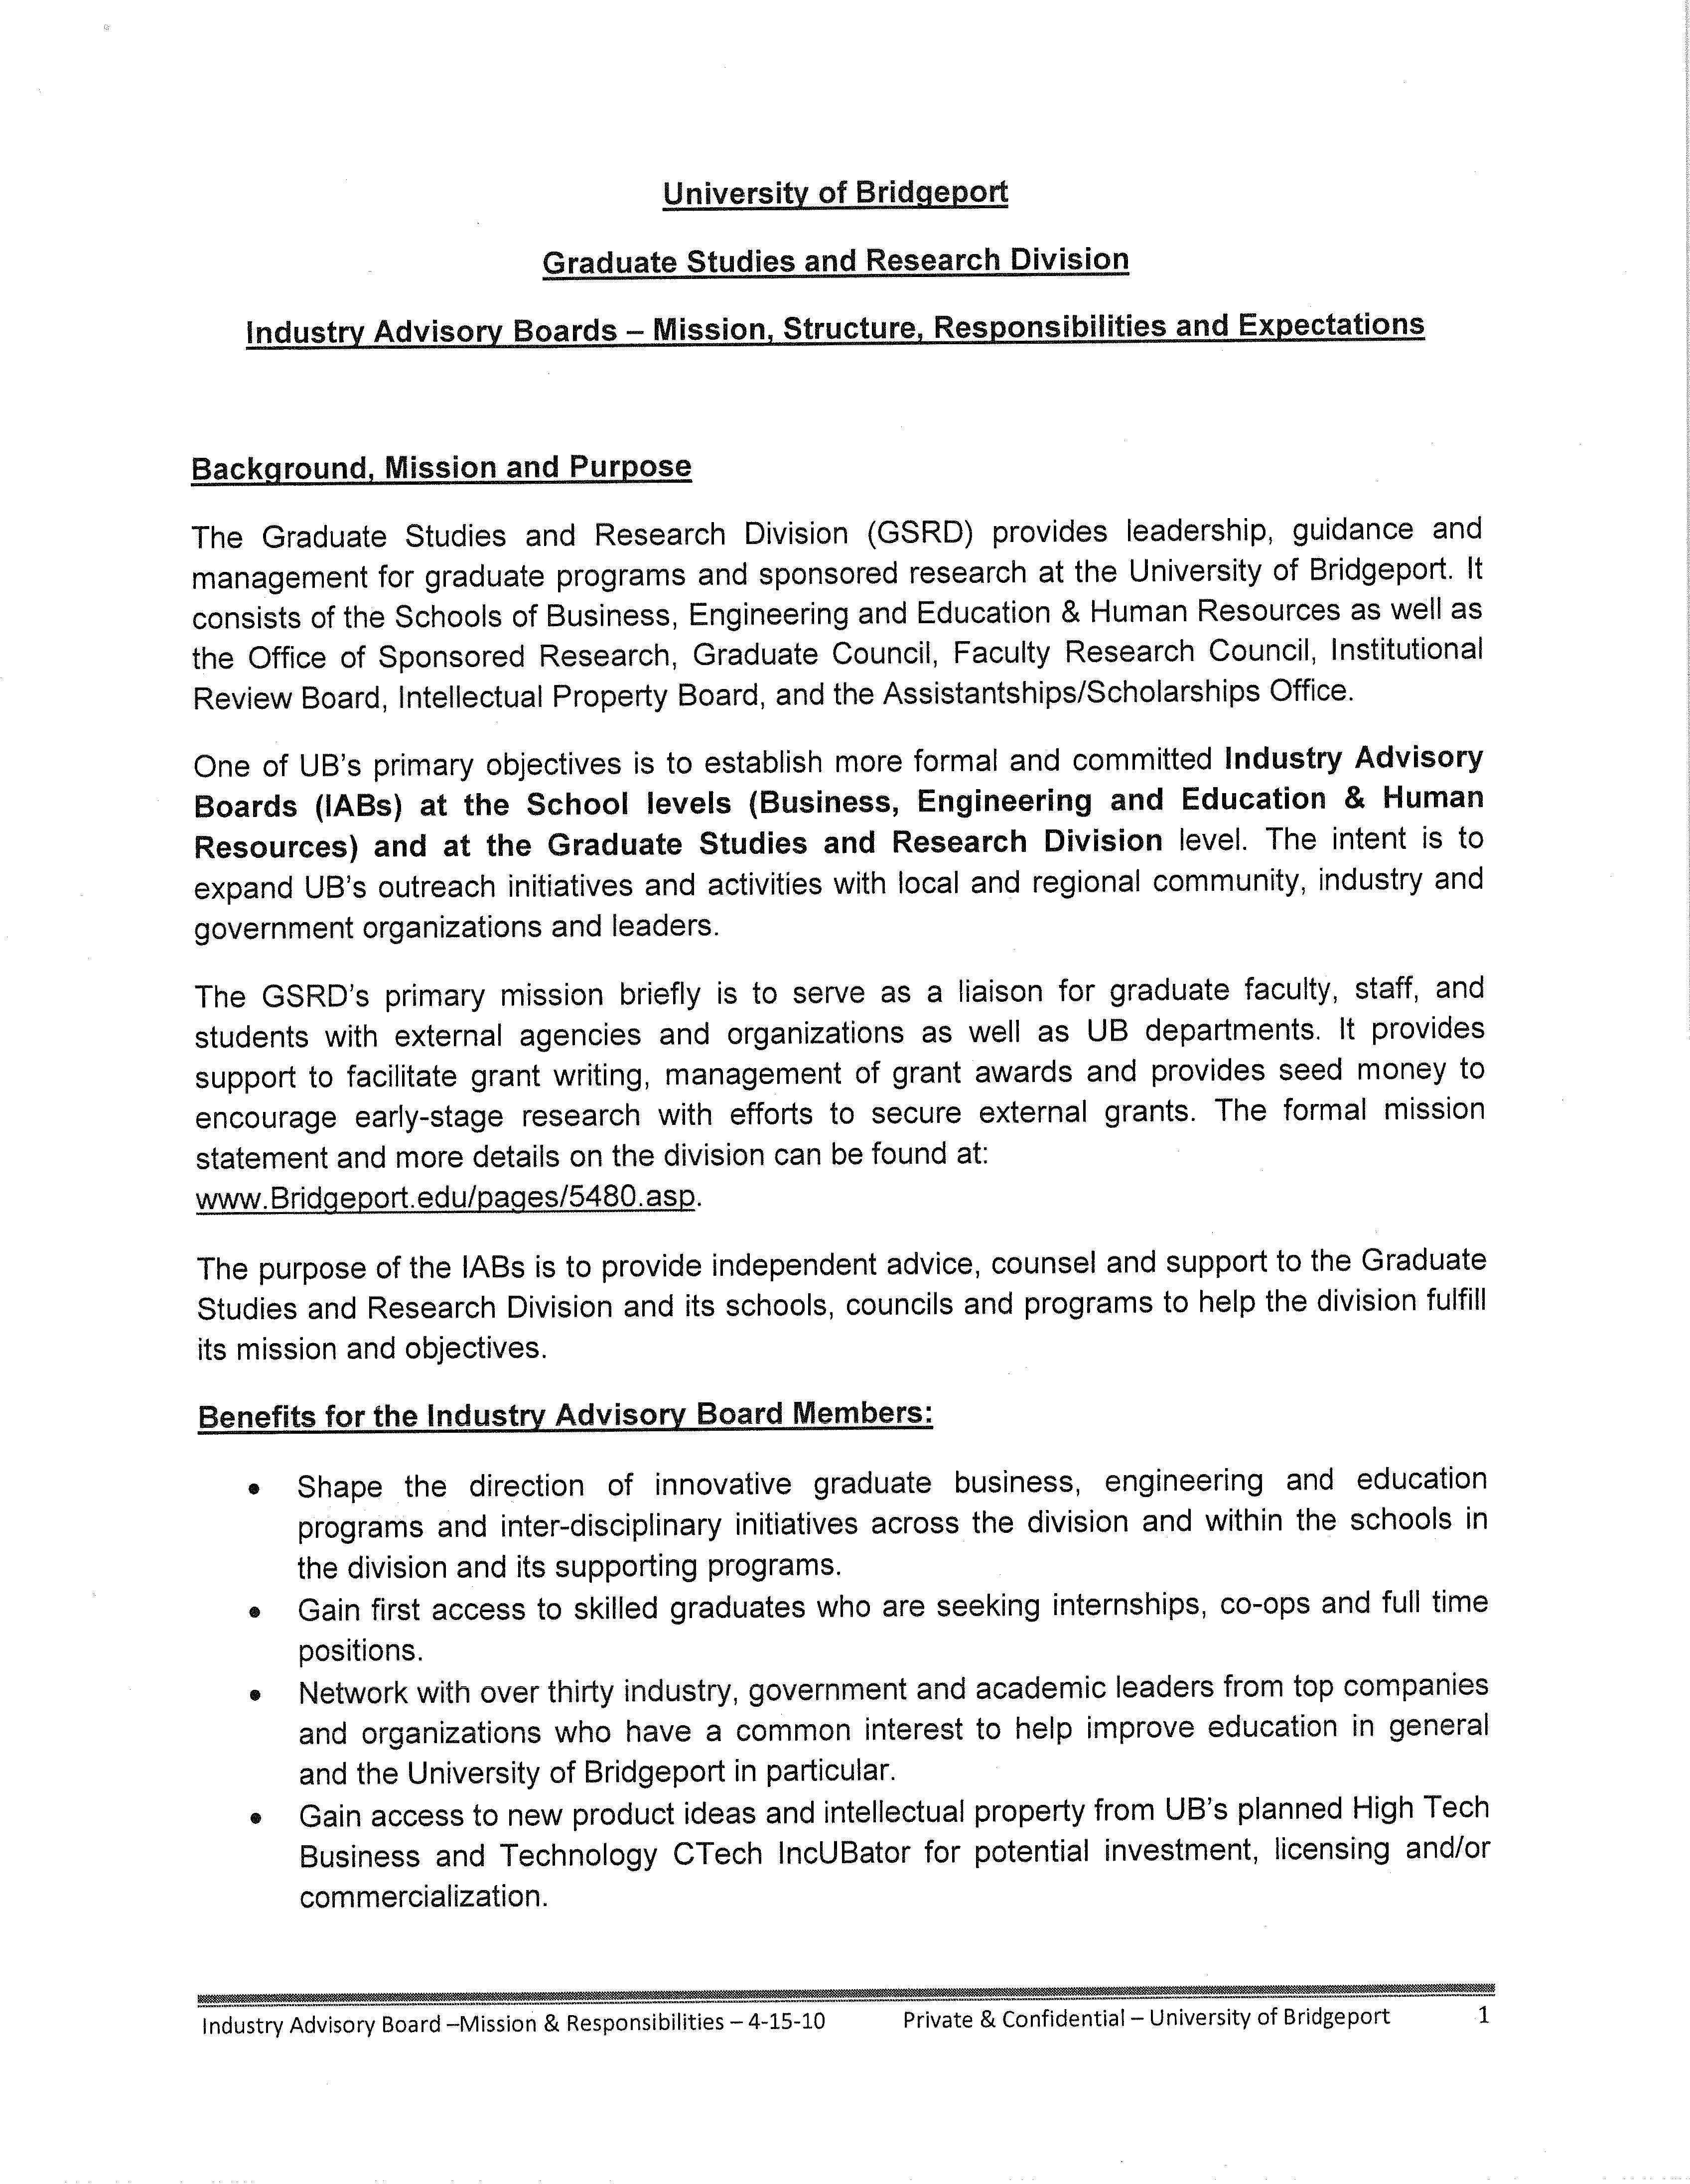
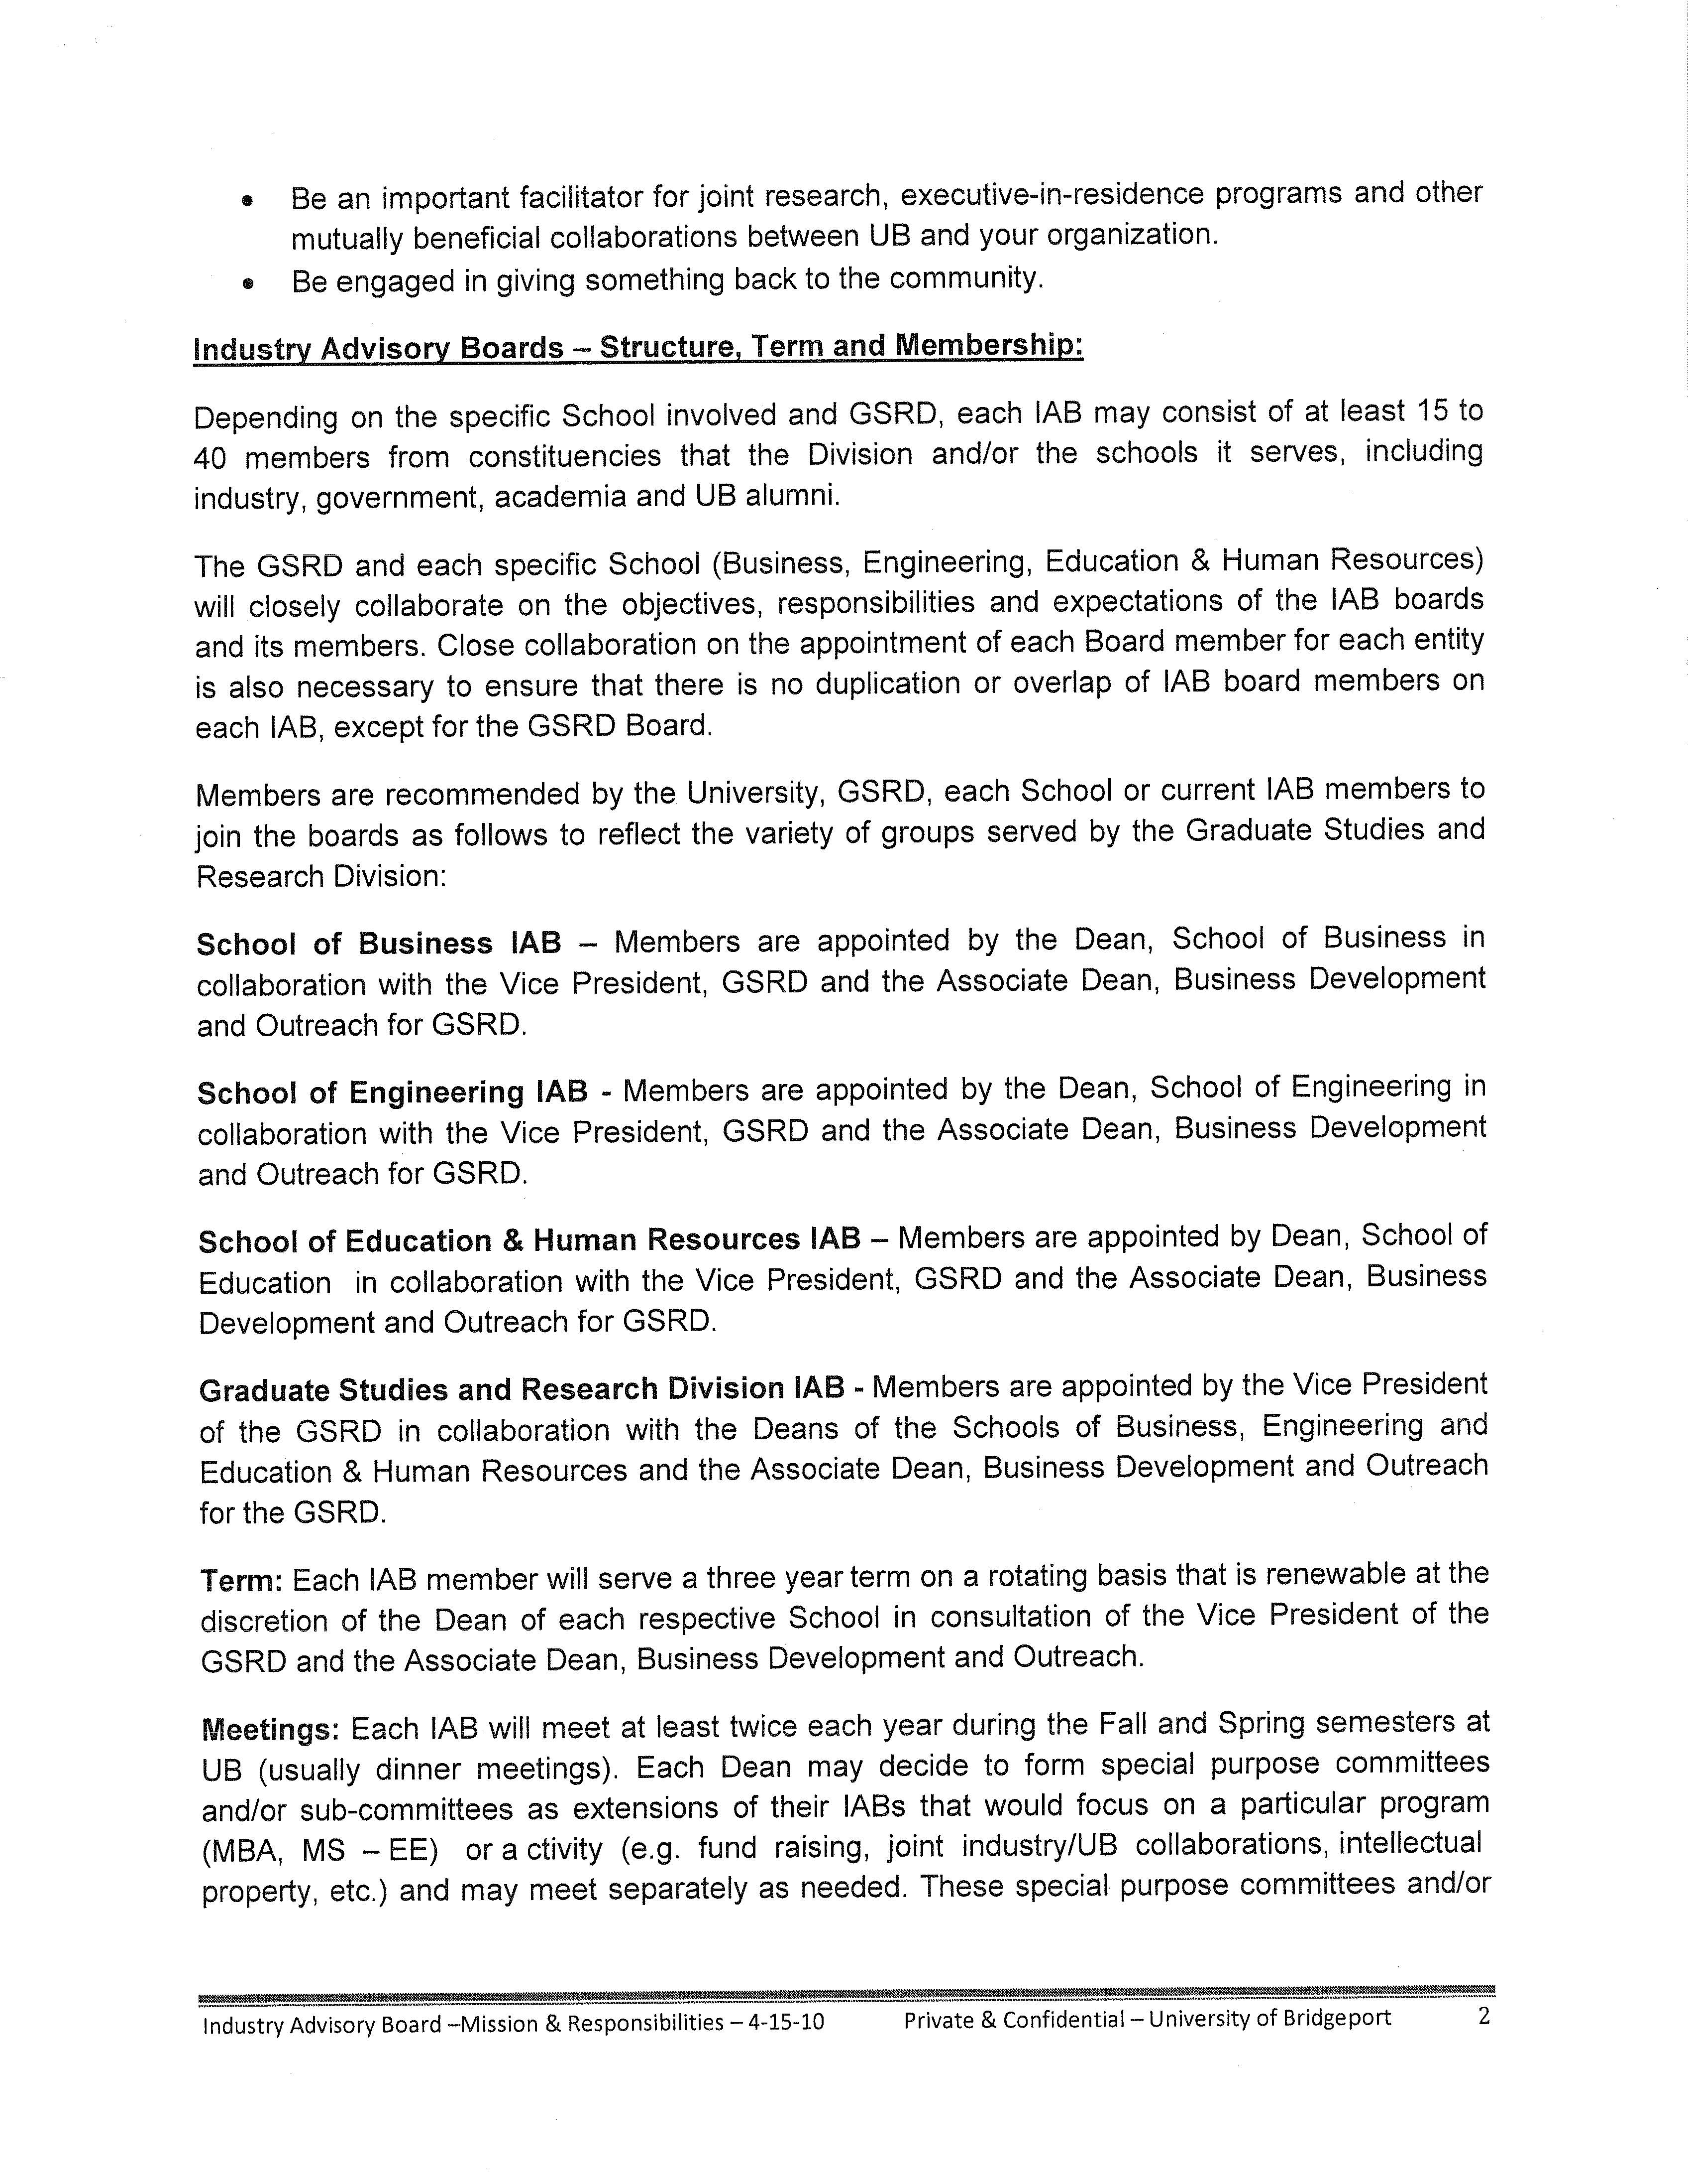
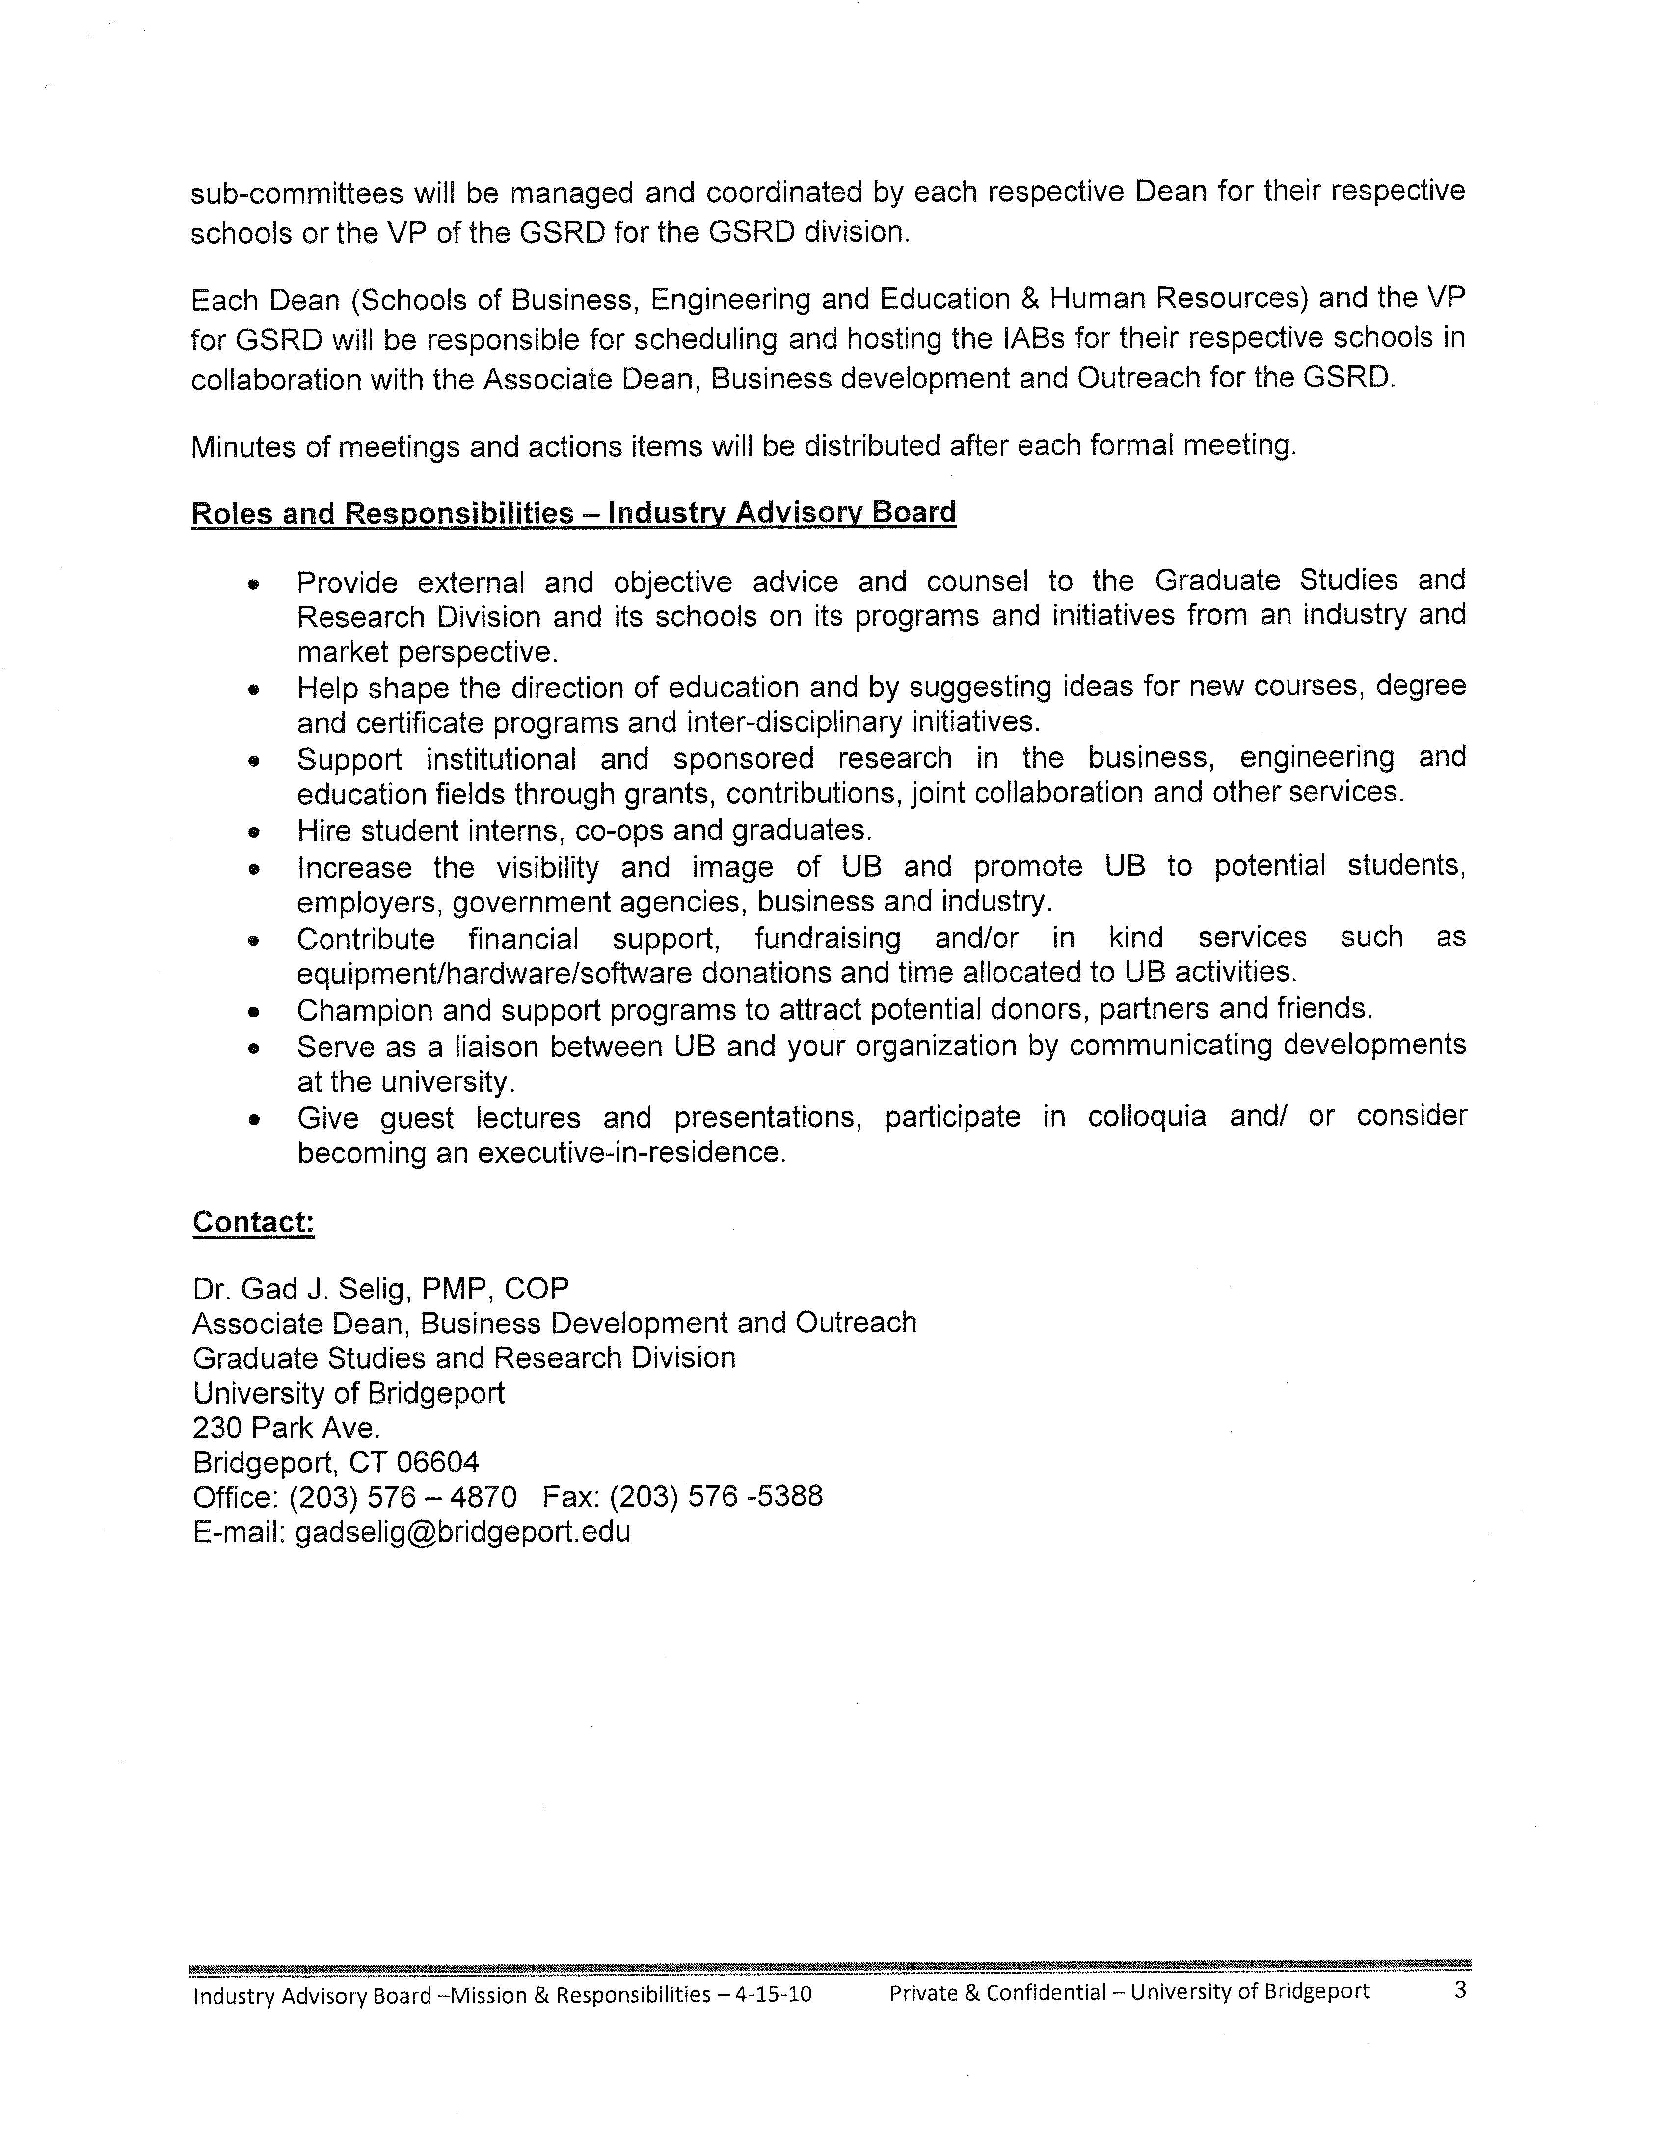

Appendix D

Co-op and Internship Companies
Co-op and Internship Companies
FA 2009 & SP 2010

Semester |  | Company
FA 09 |  | A & J's
FA 09 |  | ABAS*USA
 | SP 10 | ABC Printing & Mailing
 | SP 10 | Advanced Barcode Technology Inc.
FA 09 |  | AFC Industries
FA 09 |  | Ajiboye Software Development
FA 09 | SP 10 | All Family medical P.C.
FA 09 |  | Allure Creations Inc.
FA 09 |  | Amneal Pharmaceuticals
FA 09 |  | Avon Products Inc.
FA 09 |  | Axiom Valuation Solutions
FA 09 |  | Bank of America
FA 09 | SP 10 | Bebe
 | SP 10 | Bio-Chem Technology Lab
FA 09 |  | Blueline International LLC
 | SP 10 | Bregman & Comopany PC
FA 09 | SP 10 | Brentwood Pharmacy
FA 09 |  | Burnside Pharmacy
FA 09 |  | CCB School of New Haven
 | SP 10 | CITI Leave Management
 | SP 10 | Clarion Hotel Park Avenue
 | SP 10 | Covanta Engergy
 | SP 10 | CPN LLC
FA 09 |  | CRP Group
 | SP 10 | Dawn Mayo and Associates
FA 09 | SP 10 | Dholaria International
 | SP 10 | Dunkin Donuts
FA 09 |  | ECA
 | SP 10 | ECPI Virginia Beach Campus
 | SP 10 | EESHRAY
 | SP 10 | Electronic Interconnect
 | SP 10 | Elizabeth A. Smith Inc.
FA 09 |  | Energizer Personal Care
FA 09 |  | Enlace
FA 09 |  | Entertainment Consumers Association
FA 09 |  | Envirocitizen LLC
FA 09 |  | Executive Management Consultants
FA 09 |  | Fact Set Research Systems Inc.
FA 09 |  | Frequentis
FA 09 |  | Friendship Ambassadors Foundation
Semester |  | Company
FA 09 | SP 10 | FSW
FA 09 |  | Global Mobility Services
 | SP 10 | Grant & Simons
FA 09 |  | Greater Bridgeport Bar Association
FA 09 | SP 10 | Halper-Rawiszer Financial Group
FA 09 | SP 10 | Harborside Financial Center
FA 09 |  | Home and Hearth Designs LLC
FA 09 |  | HummingBytes
FA 09 | SP 10 | Independent Software LLC
FA 09 |  | Infoserve Technologies Institute
FA 09 | SP 10 | International Container Lines Inc
FA 09 | SP 10 | International Systems Technologies
FA 09 |  | IntiGrow
FA 09 |  | JK Merillin Builders Inc
FA 09 |  | Knight Libertas LLC
FA 09 | SP 10 | Kunkun Medical Billing Services
FA 09 |  | L & J Clothiers Inc.
FA 09 |  | LEGO Systems Inc.
 | SP 10 | Mantz Construction LLC
 | SP 10 | Marc Jacobs
FA 09 | SP 10 | Matrix Personnel Solutions Inc
FA 09 |  | Media Spa LLC
FA 09 |  | Molex Interconnect (Shanghai) Co.
 | SP 10 | Moneydart Global Services
FA 09 |  | NAFI Connecticut, Inc.
FA 09 |  | New Main Moon Buffet
 | SP 10 | New York School of Medicine
FA 09 |  | Nexus Design LLC
FA 09 | SP 10 | Nokia
 | SP 10 | OCE North America
FA 09 | SP 10 | Optimus Global Services
FA 09 | SP 10 | Outsource Partners Interantional
FA 09 |  | Papa John's
FA 09 |  | Paper Resources
 | SP 10 | Pario Group LLC
FA 09 | SP 10 | Park Hudson International
FA 09 | SP 10 | People's Bank
FA 09 |  | Pfaltz & Bauer
 | SP 10 | Prayma Technologies
 | SP 10 | PriceWaterhouseCoopers
 | SP 10 | Rogers Casey
FA 09 | SP 10 | S&L Aerosapce Metals Inc
 | SP 10 | Sam's Family Dental Care
 | SP 10 | Saraday Enterprises Inc.
Semester |  | Company
FA 09 |  | Schroth Systems Consulting Inc.
FA 09 | SP 10 | Scott Electrical Service LLC
FA 09 |  | Seven-Eleven
 | SP 10 | Shivam USA Inc
 | SP 10 | Silkland
FA 09 |  | Sitel
FA 09 |  | SRG America
FA 09 |  | Stamford Downtown Social Services
 | SP 10 | STAR4CE Technologies Inc
FA 09 |  | Stujanstar Corporation
FA 09 |  | Sublime Wireless Inc.
 | SP 10 | Subway of Lordship LLC
 | SP 10 | Sunrise Petroleum Group
FA 09 |  | Synergy Microwave Corporation
FA 09 |  | The Bank of New York Mellon
FA 09 | SP 10 | The Barnum Museum
FA 09 | SP 10 | The Stanley Works
 | SP 10 | The United Illuminating Co.
FA 09 |  | UB Dept of Athletics
 | SP 10 | Utica Hospitality Inc
FA 09 |  | WNBA Atlanta Dream
FA 09 |  | World Quaint

Appendix E

Research Equipment Grants
Research Equipment Grants FY 2009-10

FY | PI/Project Director | Project Title | Sponsor | Request Type | Original Acquisition Cost | Award Period
2009-10 | Bach, C. | IBM X3550 M2 Performance Servers (3) LOAN | IBM | Equipment Loan | $40,000 | 4/7/2010-
2009-10 | Patra, P. | Gas Chromatograph | US Dept of Energy | Equipment | $13,899 | 10/26/2009- 10/25/2010
2009-10 | Patra, P. | Microplate Dispenser | US Dept of Energy | Equipment | $14,000 | 11/20/2009- 11/19/2010
2009-10 | Patra, P. | Electrophoresis & Pump | US Dept of Energy | Equipment | $27,000 | 12/2/2009- 12/1/2010
2009-10 | Patra, P. | Zeiss Microscope | US Dept of Energy | Equipment | $30,299 | 12/4/2009- 12/3/2010
2009-10 | Patra, P. | Transmission Electron Microscope | US Dept of Energy | Equipment | $49,500 | 2/25/2010- 2/24/2011
2009-10 | Patra, P. | Lab Microwave, Microwave Muffle | US Dept of Energy | Equipment | $8,500 | 3/3/2010- 3/2/2011
2009-10 | Zhang, L. | Microscope | US Dept of Energy | Equipment | $10,000 | 7/3/2009 - 7/2/2010

Research Equipment Grants FY 2008-09

FY | PI/Project Director | Project Title | Sponsor | Request Type | Original Acquisition Cost | Award Period
2008-09 | Sobh, T. | Wireless micro-camera system, video receiver, DV converter, wireless modules, PC interface board, 2 precision workstations with monitors, Thinkpad notebook computer, wireless target board, Code Composer | ARDEC | Equipment | $11,190 | 8/1/2008- 5/31/2009
2008-09 | Xiong, X. | HP Multimeter | US Dept of Energy | Equipment | $10,000 | 6/28/2009- 6/27/2010
2008-09 | Zhang, L. | Microanalyzer System | US Dept of Energy | Equipment | $660,000 | 6/11/2009 - 6/10/2010
2008-09 | Zhang, L. | Gas Spectrometer | US Dept of Energy | Equipment | $30,000 | 6/24/2009- 6/23/2010

Appendix F

Awarded and Pending Research Grants
2009-2010

Awarded and Pending Research Grants 2009-2010 (as of May 1, 2010)

FY | PI/Project Director | Project Title | Sponsor | Request/ Value | Award/ Value | Status | Award Period
2009-10 | Hu, J. | Fundamental Study of Shielding Gas Effects in Gas Metal Arc Welding | NSF | $344,859 |  | Pending
2009-10 | Lee, J. | III: Small: Collaborative Research: Smart Browsing System for Endoscopy Videos | NSF | $147,635 |  | Pending
2009-10 | Lee, J. | RI: Small: Collaborative Research: Semantic Video Synopsis for Large-Scale Video Data | NSF | $297,371 |  | Pending
2009-10 | Patra, P. | Acquisition of a Nanospider System for Nanofabrication Research and Teaching | NSF | $151,723 |  | Pending
2009-10 | Sobh, T. | Design and Implementation of the Hybrid Projectile - Travel Funds | ARDEC/Imperial Machine Co. | $5,000 | $5,000 | Awarded | 9/5/2009- 10/5/2009
2009-10 | Sobh, T. | Design and Implementation of the Hybrid Projectile | ARDEC/Imperial Machine Co. | $30,000 | $30,000 | Awarded | 3/25/2010- 7/31/2010
2009-10 | Sobh, T. | Design and Implementation of the Hybrid Projectile | ARDEC/Imperial Machine Co. | Part of $2.4 million | TBA | Awarded | TBD
2009-10 | Sobh, T. | LexAR: Collaborative Construction of Arabic Lexical Resources | PSUT/Qatar Foundation | $43,590 |  | Pending
2009-10 | Wei, C. | Rationality, Misperception and Political Contexts: Cross-Taiwan-Strait Relationships as a Nested Game | Chiang Ching-Kuo Foundation | $15,300 |  | Pending
2009-10 | Xiong, X. | CCLI Phase II: Class on a Chip | Texas Tech U/NSF | $48,158 |  | Pending
FY | PI/Project Director | Project Title | Sponsor | Request/ Value | Award/ Value | Status | Award Period
2009-10 | Zhang, L. | A Nationwide Consortium of Universities to Revlitalize Electric Power Engineering Education by State-of-the-Art Laboratories | U of Minnesota/US Dept of Energy | $25,000 | TBA | Awarded | TBD
2009-10 | Zhang, L. | BRIGE: The Fundamental Study of the Interaction between Hydrogen and the Palladium/Insulator Interface | NSF | $174,850 |  | Pending
2009-10 | Zhang, L. | MRI: Acquisition of a Thin Film Growth System for Interdisciplinary Research and Education at the University of Bridgeport | NSF | $202,954 |  | Pending

Appendix G

Licenses and Software Contributions
2009-2010

Licenses/Software Contributed 2009-2010

FY | License/Software | Sponsor | Award Value
2009-10 | Max + plus II 10.2 Baseline | Altera | $180,000
2009-10 | ANSYS II | ANSYS | $1,305,800
2009-10 | FlowLab | ANSYS | $1,000
2009-10 | Pspice student (ORCAD 15.7) | Cadence Design Systems, Inc. | $750
2009-10 | OrCAD 15.7 | Cadence Design Systems, Inc. | $98,000
2009-10 | Star-CCM+ | CD-adapco | $120,000
2009-10 | Star-design | CD-adapco | $10,000
2009-10 | Start-CD-Adapco | CD-adapco | $162,500
2009-10 | Delmia | Delmia | $88,000
2009-10 | Lingo | Lingo | $6,125
2009-10 | Matlab 2007a | MathWorks | $838,800
2009-10 | Flotherm | Mentor Graphics | $19,000
2009-10 | Mentor Graphics | Mentor Graphics | $168,800
2009-10 | Microsoft Visual Studio 2005 | Microsoft | $997,603
2009-10 | MSC.Software | MSC Corporate | $56,500
2009-10 | Labview | National Instruments Corporation | $125,001
2009-10 | ETAP | Operation Technology, Inc. | $300,000
2009-10 | OPNET IT Guru/Modulator | Opnet | $348,000
2009-10 | Oracle | Oracle | $2,979,460
2009-10 | Palisade StatTools | Palisade | $225
2009-10 | Palisade @ RISK | Palisade | $195
2009-10 | PTC (PRO Engineer) | PTC Corporate | $168,000
2009-10 | Redhat | Redhat | $500
2009-10 | Rockwell Software (Arena 10.0) | Rockwell Automation | $550
2009-10 | Synopsys | Synopsys | $177,000
 |  |  | $8,151,809

Appendix H

A Sample of UB Faculty Scholarly Works




University of Bridgeport

A Sample of Recent Faculty
Publications and Scholarly Activities

May 1, 2010

Sample of Recent Journal Papers

2010 Publications:
Kunduru, V., Bothara, M., Grosch, J., Sengupta, S., Patra, P. K., & Prasad, S. (2010).
Nanostructured surfaces for enhanced protein detection toward clinical diagnostics. Nanomedicine: NBM 2010; xx:1-9. doi: 10.1016/j.nano.2010.03.002
Lisi, A. J. (2010). Management of operation Iraqi freedom and operation enduring freedom
veterans in a veterans health administration chiropractic clinic: A case series. Journal of Rehabilitation Research and Development, 47(1), 1-6.
Passmore, S. R., Burke, J. R., Good, C., Lyons, J. L., & Dunn, A. S. (2010). Spinal manipulation
impacts cervical spine movement and Fitts’ task performance: A single-blind randomized before-after trial. Journal of Manipulative and Physiological Therapeutics, 33(3), 189-192.
Rivzi, S. S., Riasat, A., & Elleithy, K. M. (2010). Deterministic formulization of end-to-end
delay for multicast systems. International Journal of Computer Networks & Communications, 2 (1), 170-183.
Sagner, J. S. (2010). Your vanishing vendors: Lessons from bank M&As. The Journal of
Corporate Accounting & Finance, 21 (2), 25.
Toporovsky, J., Hempowicz, C., & Sobh, T. M. (2010). Interdisciplinary automation and control
in a programmable logic controller (PLC) laboratory. International Journal of Engineering, 4 (1), 79-85.
Wei, Chunjuan Nancy (2010). China’s anti-secession law and Hu Jintao’s Taiwan policy. Yale
Journal of International Affairs, 5 (1), 112-127.
Wise, S. S., Holmes, A. L., Qin, Q., Xie, H., Katsifis, S. P., Douglas Thompson, W., & Wise, Sr.,
J.P. (2010) Comparative genotoxicity and cytotoxicity of four hexavalent chromium compounds in human bronchial cells. Chemical Research in Toxicology, 23 (2), 365-372.

2009 Publications:
Abuhelaleh, M. A., Elleithy, K. M., & Mismar, T. M. (2009). Clustered hierarchy in sensor
networks: Performance and security. International Journal of Network Security & Its Applications, 1(2), 51-62.
Bach, D., Sarkis, J., & Zhang, J. (2009). Toward the use of internal marketing in networks.
International Journal of Business Excellence, 2(1), 30-49.
Barkana, B. D., Gupta, N., & Hmurcik, L. V. (2009) Two case reports: Electrothermal (aka
contact) burns and the effects of current density, application time and skin resistance. Burns, IN PRESS
Benjamin, D. O. (2009). From collective to human security: Development and peace in the 21st
century. Journal of Global Development and Peace, Spring, 44-55.
Benjamin, D. O. (March 2009). Protecting the protectors: NGO action and the responsibility to
protect. International Journal of World Peace, 26(1), 31-50.
Chen, M., Patra, P. K., Lovett, M. L., Kaplan, D. L., & Bhowmick, S. (2009). Role of
electrospun fibre diameter and corresponding specific surface area (SSA) on cell attachment. Journal of Tissue Engineering and Regenerative Medicine, 3(4), 269-279. doi: 10.1002/term.163
Elkady, A. Y., Mohammed, M., & Sobh, T. (2009). A new algorithm for measuring and
optimizing the manipulability index. Journal of Intelligent and Robotic Systems: Theory and Applications, 1-12. IN PRESS.
Eschenbach, T. G., Lewis, N. A., & Hartman, J. C. (2009). Technical note: Waiting cost models
for real options. Engineering Economist, 54(1), 1-21.
Funk, M. F., & Lisi, A. J. (2009). Conflict of interest policies among institutions and
organizations offering chiropractic continuing education. Journal of Manipulative and Physiological Therapeutics, 32(4), 303-308.
Good, C. J. (2009). Student-generated case reports. The Journal of Chiropractic Education, 23
(2), 165-173.
Goyal, A., Kumar, A., Patra, P. K. Mahendra, S., Tabatabaei, S., Alvarez, P. J. J., John, G.
Ajayan, P. M. (July 2009). In situ synthesis of metal nanoparticle embedded free standing multifunctional PDMS films. Macromolecular Rapid Communications, 30(13), 1116-1122. doi: 10.1002/marc.200900174
Guo, H., Hu, J., & Tsai, H. L. (2009). Formation of weld crater in GMAW of aluminum alloys.
International Journal of Heat and Mass Transfer, 52(23-24), 5533-5546.
Kawchuk, G. N., & Perle, S. M. (2009). The relation between the application angle of spinal
manipulative therapy (SMT) and resultant vertebral accelerations in an in situ porcine model. Manual Therapy, 14(5), 480-483.
Kongar, E., & Gupta, S. M. (2009). Solving the disassembly-to-order problem using linear
physical programming. International Journal of Mathematics in Operational Research, 1(4), 504-531.
Kongar, E., Kontogiorgis, P., Russo, N. L., & Sobh, T. M. (2009). Women in science,
engineering and technology: Changing roles and perception within the technical services industries. Journal of Engineering and Applied Sciences, 4(1), 46-50.
Kongar, E., Sobh, T. M., & Baral, M. (2009). Two-step data envelopment analysis approach for
efficient engineering enrollment management. International Journal of Engineering Education, 25(2), 391-402.
Lee, J. (2009). Message from the program chair. Proceedings – International Workshop on
Database and Expert Systems Applications, DEXA, art. No 5337269, xxv.
Lee, S. M., Kim, G. H., & Kim, J. (2009). Comparative feasibility analysis of Wi-Fi in
metropolitan and small municipalities: A system dynamics approach. International Journal of Mobile Communications, 7(4), 395-414.
Lewis, N., Eschenbach, T., & Hartman, J. (2009). Real options and the use of discrete and
continuous interest rates. ASEE Annual Conference and Exposition, Conference Proceedings.
Li, J. (Z). (2009). Computational modeling and design of a new open clip surgical instrument.
International Journal of Surgery, 7(4), 373-376.
Li, J. (Z). (May 2009). Study and development of a new mechanism in an endoscopic surgical
instrument. International Journal of Recent Trends in Engineering, 1(5), 122-124.
Li, J. (Z). (May 2009). Study and development of an energy saving mechanical system.
International Journal of Trends in Engineering, 1(5), 51-54.
Lisi, A. J. (2009). Managing conflicts of interest in continuing medical education: A comparison
of policies. The Journal of Chiropractic Education, 23 (1), 36-39.
McCullen, E., Auner, G. W., Ng, K. Y. S., Rimai, L., Zhang, L., & Naik, R. (October 2009). The
sensing mechanism and the response simulation of the MIS hydrogen sensor. IEEE Sensors Journal, 9(10), 1196-1201. doi: 10.1109/JSEN.2009.2029450
Mohammed, M., Elkady, A., & Sobh, T. (2009). A new algorithm for measuring and optimizing the manipulability index. International Journal of Advanced Robotic Systems, 6(2), 145-150.
Noe, J. E. (2009). L-Glutamine use in the treatment of prevention of mucositis and cachexia: A
naturopathic perspective. Integrative Cancer Therapies, 8(4), 409-415. doi: 10.1177/1534735409348865
Rao, Z. H., Hu, J., Liao, S. M., & Tsai, H. L. (2009). Determination of equilibrium wire feed
speeds for a stable gmaw process. ASME International Mechanical Engineering Congress and Exposition, Proceedings 10 (PART C), 1723-1733.
Ray, S., Guha, R. K., Yasen, W., & Austin, M. (2009). SAPLER: An optimal MAC algorithm
for wireless instrumentation systems. IEEE International Conference on Communications, art. No. 5199432.
Razdan, S., Patra, P. K., Kar, S., Ci, L., Vajtai, R., Kukovecz, A., Kiricsi, I., Konya, Z., Ajayan,
P. M. (2009). Ionically self-assembled polyelectrolyte-based carbon nanotube fibers. Chemistry of Materials, 21(14), 3062-3071. doi: 10.1021/cm803060d
Reddy, C. S., Katra, P. K., & Das, C. K. (2009). Ethylene-octene copolymer-nanosilica
nanocomposites: Effects of epoxy resin functionalized nanosilica on morphology, mechanical, dynamic mechanical and thermal properties. Macromolecular Symposia, 277(1), 119-129. doi: 10.1002/masy.200950315
Resick, C. J., Whitman, D. S., Weingarden, S. M., & Hiller, N. J. (2009). The bright-side and the
dark-side of CEO personality: Examining core self-evaluations, narcissism, transformational leadership, and strategic influence. Journal of Applied Psychology, 94 (6), 1365-1381. doi: 10.1037/a0016238
Rizvi, S. S., Elleithy, K. M., & Riasat, A. (2009). Analyzing SNR performance of a low-
complexity wireless multiuser receiver for DS-CDMA systems. 2009 2nd International Conference on Computer, Control and Communication, IC4 2009, art. No. 4909239.
Rizvi, S. S., Khan, M. A., & Riasat, A. (2009). Deterministic formulization of bandwidth
efficiency for multicast systems. 2009 2nd International Conference on Computer, Control and Communication, IC4 2009, art. No. 4909237.
Rizvi, S. S., Khan, M. A., & Riasat, A. (2009). Active scanning: A better approach to reduce
handover time at MAC layer for wireless networks. 2009 2nd International Conference on Computer, Control and Communication, IC4 2009, art. No. 4909172.
Rosentrater, K.A., & Kongar, E. (2009). Modeling the effects of pelleting on the logistics of
distillers grains shipping. Bioresource Technology, 100(24), 6550-6558.
Sagner, J. S. (2009). Bank loan covenant measures and mis-measures. North American Journal
of Finance and Banking Research, 3 (3), 55-68.
Sagner, J. S. (2009). How to measure and manage liquidity today. The Journal of Corporate
Accounting & Finance, 21 (1), 47.
Weaver, A. C., & Wu, Z. (2009). Using web service enhancements to establish trust relationships
with privacy protection (Extended and Invited from ICWS 2006 with id47). International Journal of Web Services Research, 6(1), 49-68.
Whitman, D.S., van Rooy, D. L., Viswesvaran, C., & Draus, E. (2009). Testing the second-order
factor structure and measurement equivalence of the Wong and Law emotional intelligence scale across gender and ethnicity. Educational and Psychological Measurement, 69(6), 1059-1074.

Wu, Z. (2009). A semantic approach for trust information exchange in federation systems.
Proceedings – International Conference on Advanced Information Networking and Applications, AINA, art. No. 5136619, 25-30.
Wu, Z., & Wang, L. (2009). An enforcement architecture for security and trust policies in
federated web-service-based systems. Proceedings – International Computer Software and Applications Conference 2, art. No. 5254067, 329-334.
Xiong, X., Zhang, L., Hu, J., & Hnurcik, L. (2009). Introducing the small world-developing
MEMS/nanotechnology curriculum. ASEE Annual Conference and Exposition, Conference Proceedings.
Zhang, L., Wiong, X., & Hu, J. (2009). Integrating alternative energy technology into
engineering education. ASEE Annual Conference and Exposition, Conference Proceedings.

2008 Publications:
Azizi, N. (2008). Fracture of the tibial intercondylar eminence: A case report. Clinical
Chiropractic, 11(4), 205-210.
Barkana, B. D. (2008). Characteristics of AIGaAs/GaAs heterostructure RT-SCR model.
Microelectronics Journal, 39(12), 1504-1508.
Brady, D., Gastrointestinal Function (2008). In J. A.Bralley & R. S. Lord, (Eds), Laboratory
Evaluations for Integrative and Functional Medicine, (pp.416-458). Metametrix
Institute.
Brady, D. M. (2008). DNA detection of gut microbiota using polymerase chain reaction
(PCR) Technology. Naturopathic Doctor News & Review, 4(1).
Brady, D. M. (2008, July/August). Diagnostics spotlight: DNA-PCR-based stool analysis.
Journal of Complementary Medicine, 28-31.
Brady, D. M. (2008, Jul). Novel options in gastrointestinal diagnostics. Nutritional
Perspectives, 31(3), 5-7.
Calvert, P., Duggal, D., Patra, P., Sawhney, A. (2008). Conducting polymer and conducting
composite strain sensors on textiles. Molecular Crystal and Liquid Crystal, 484, 657-
668. doi: 10.1080/15421400801904690
Efendigil, T., Önut, S., & Kongar, E. (March 2008). A holistic approach for selecting a third-
party reverse logistics provider in the presence of vagueness. Computers & Industrial Engineering, 54(2), 269-287. doi: 10.1016/j.cie.2007.07.009
Funk, M. F., Lisi, A. J. (2009). Conflict of interest policies among institutions and
organizations offering chiropractic continuing education. Journal of Manipulative and
Physiological Therapeutics, 32(4), 303-308.
Garcia, W. M., Greco, L. (2008). Post Traumatic Stress Disorder: Treatment with
Confidence, Competence and Compassion, Access, 22(6), 30-33.
Good, C., Sherman, P. (2008, Nov). AIR S+M: Transforming PARTS into a Systematic
Vertebral Subluxation/Joint Dysfunction Analysis Method. The Journal of the American
Chiropractic Association (JACA), 14-16.
Healey, S. (2008). Atheism, pluralism, and Godism: A dialogue of Sigmund Freud, William
James, and Unification Thought. Journal of Unification Thought.
Jeon, S., Yoon, S. N., Kim, J. (2008). A cross cultural study of corporate blogs in the U.S.
and in Korea. International Journal of Information Technology and Management, 7(2),
149-160.
Lee, S. M., Kim, G., Park, S. (2008). Assessing municipal wireless network projects: The
case of Wi-Fi Philadelphia. Electronic Government, an International Journal, 5(3),
227-246.
Lee, S. M., Yoon, S. N. (2008). The Effect of pluralistic ignorance on the Internet abuse at
workplace. Journal of Computer Information Systems, 48(3).
Lehman, J. J., Conwell, T. D., & Sherman, P. R. (2008). Should the chiropractic profession
embrace the doctrine of informed consent? Journal of Chiropractic Medicine, 7(3), 107-114.
Lehman, J. J., Suozzi, P. J., (2008 Spring). Founding integrative medicine centers of
excellence: One strategy for chiropractic medicine to build higher cultural authority. Journal of Chiropractic Education, 22(1), 29–33.
Murphy, D. R., Schneider, M. J., Seaman, D. R., Perle, S. M., Nelson, C. F. (2008 Aug 29).
How can chiropractic become a respected mainstream profession? The example of
podiatry. Chiropractic & Osteopathy, 16(1), 10.
Neussl, A. (2008). Mouthguards in the American Hockey League [AHL]. Journal of Dental
Hygiene: JDH/American Dental Hygienists’ Association, 82(5), 44.
Ngoh, N.N. (2008). Confounding variables as impediments to validity in the measurement
of skill aAttainment. Journal for the Advancement of Educational Research, 4(1).
Passmore, S. R., Burke, S. R., Good, C., Lyons, J. L., & Dunn, C. (2008, June). Cervical spine
movement and Fitts’ task performance after spinal manipulation (abstract). Journal of Sport and Exercise Psychology, Supplement, 30, S119-S120.
Patterson, J., Reed, D., Goens, G. A. (2008, December). Joy and resilience: Strange
bedfellows. The School Administration, 65(11), 28-29.
Robertson, R. J., Goss, F. L., Aaron, D. J., Gairola, A., Kowallis, R. A., Liu, Y., Randall, C.
R., Tessmer, K. A., Schnorr, T. L., Schroeder, A. E., White, B. (2008 January). One repetition maximum prediction models for children using the OMNI RPE Scale. Journal of Strength and Conditioning Research, 22(1), 196-201.
Sarkar, S., & Ray, S. (2008). Arbitrary throughput versus complexity tradeoffs in wireless
networks using graph partitioning. IEEE Transactions on Automatic Control, 53(10), 2307-2323.
Spurlock, D. G., Cox, L. R., Lewis, N. A., Lueck, G. A. (2008). A content analysis of
data collection and analysis techniques as reported in the engineering management literature. Engineering Management Journal, 20(2), 46-55.
Sherman, P. R., Lehman, J. J. (2008 May-June). Abdominal aortic aneurysm (AAA)
evaluation and management by a Doctor of Chiropractic. The Journal of the American
Chiropractic Association (JACA), 45(4), 12-8.
Xiong, X., Wu, Y. –L., & Jone, W. –B. (August 2008). Yield analysis for self-repairable MEMS
devices. Analog Integrated Circuits and Signal Processing, 56(1-2), 71-81.
Xu, G., Hu, J., & Tsai, H. L. (2008). Three-dimensional modeling of arc plasma and metal
transfer in gas metal arc welding. International Journal of Heat and Mass Transfer, 52(7-8), 1709-1724.
Yu, Y. (2008). Corruption, impact of corruption, and measures to curtail corruption.
In S. Guo & B. Guo (Eds.), China in Search of a Harmonious Society (pp. 229-238).
Lexington Books: Rowman & Littlefield Publishing group, Inc.

University of Bridgeport

A Sample of Recent Faculty
Publications and Scholarly Activities

Sample of Recent Conference Papers
2010

2010 Publications:
Li, Z. (2010). Design and development of a new magnetic sealing mechanism in reciprocating
machinery. Portugal. Pending approval.
2009 Publications:
Abuhelaleh, M. A., Elleithy, K. M., & Mismar, T. M. (2009, April). Routing in sensor networks:
Performance and security in clustered networks. Paper presented at the Northeast American Society of Engineering Education Conference (ASEE’09), Bridgeport, CT.
Bajwa, H., Patra, P., Xiong, X. (2009, April). Nanotechnology curriculum initiative in
connecticut. Paper presented at the Northeast American Society of Engineering Education Conference (ASEE’09), Bridgeport, CT.
Barkana, B., Gupta, N., & Hmurcik, L. V. (2009, June). Improving tools and techniques of
teaching graduate engineering courses based on students’ learning styles and multiple intelligences. Paper presented at the Northeast American Society of Engineering Education Conference (ASEE), Austin, TX.
Barkana, B., Patel, S., Gupta, N., & Hmurcik, L. V. (2009, April). Using real life cases to
teach students about electric burns-Part I Contact Burns. Paper presented at the Northeast American Society of Engineering Education Conference (ASEE’09), Bridgeport, CT.
Barkana, B. D., Gupta, N., & Hmurcik, L.V. (2009). Improving teaching tools and techniques of
graduate engineering courses based on students’ learning styles and multiple intelligences. Paper presented at the Northeast American Society of Engineering Education Conference (ASEE), San Antonio, TX.

Barkana, B. D., Patel, S., Gupta, N., & Hmurcik, L. V. (2009, April). Using real life cases to
teach students about electric burns-Part I Secondary burns. Paper presented at the Northeast American Society of Engineering Education Conference (ASEE’09), Bridgeport, CT.
Barkana, B. D., Patel, S., Gupta, N., & Hmurcik, L. V. (2009, April). Using real life cases to
teach students about electric burns-Part II Secondary burns. Paper presented at the Northeast American Society of Engineering Education Conference (ASEE’09), Bridgeport, CT.
Chen, Y., Yasen, W., Lee, J., Lee, D., & Kim, Y. (2009, Feb.). Developing assessment system for
wireless capsule endoscopy video based on event detection. Paper presented at the SPIE Medical Imaging, Orlando, FL.
Dong, H., & Xiong, X. (2009, April). Design and analysis of a MEMS vibratory comb
gyroscope. Paper presented at the Northeast American Society of Engineering Education Conference (ASEE’09), Bridgeport, CT.
Eschenbach, T., Lewis, N., & Hartman, J. (2009 May). The cost to keep a real deferral option
open. Paper presented at the Industrial Engineering Research Conference, Miami, FL.
Gupta, N., Barkana, B., & Hmurcik, L. V. (2009, June). Comparative study of binaural sound
generation using two HRTF databases. Paper presented at the Northeast American Society of Engineering Education Conference (ASEE), Austin, TX
Han, Y., Xiong, X., & Bajwa, H. (2009, April). A low power CMOS comparator using logic
shut-down technique. Paper presented at the Northeast American Society of Engineering Education Conference (ASEE’09), Bridgeport, CT.
Han, Y., Xiong, X., & Bajwa, H. (2009, April). A Low Power CMOS Comparator Using Logic
Shut-down Technique. Paper presented at the Northeast American Society of Engineering Education Conference (ASEE’09), Bridgeport, CT.
Imran, M., Shaikh, A., Rizvi, S. S., & Elleithy, K. M. (2009, April). Performance analysis of
switches in high speed LAN. Paper presented at the Northeast American Society of Engineering Education Conference (ASEE’09), Bridgeport, CT.
Joshi, M., Kotakonda , K., Gupta, N., & Barreto, A. (2009, June). Improving intelligibility of
teleconferences using binaural sounds. Paper presented at the 6th International Conference on Remote Engineering and Virtual Instrumentation, Bridgeport, CT
Joshi, M., Patel, S., & Hmurcik, L. V. (2009, April). Using wavelets in 1- dimension for
smoothening EKG waveforms. Paper presented at the American Society of Engineering Education Northeast Section Conference, Bridgeport, CT
Joshi, M., Patel, S., & Hmurcik, L. V. (2009, April). EKG De-noising using 2-D wavelet
techniques. Paper presented at the American Society of Engineering Education Northeast Section Conference, Bridgeport, CT.
Karuppannan, K., Xiong, X., Zhang, L., & Hu, J. (2009, April). Fault simulation of surface-
micromachined MEMS accelerometer. Paper presented at the Northeast American Society of Engineering Education Conference (ASEE’09), Bridgeport, CT.
Karuppannan, K., Xiong, X., Zhang, L., & Hu, J. (2009, April). Fault simulation of surface-
micromachined MEMS accelerometer. (ASEE) Northeast Section Conference, Bridgeport, CT.
Kim, H., Chang, J., Liu, H., Lee, J., & Lee, D. A. (2009, November). Novel image matching
method using biological gene sequence alignment. (IEEE) International Conference on Image Processing, Cairo, Egypt.
Kongar, E., & Rosentrater, K. (2009, April). A multiple criteria decision making model for
renewable energy technology selection, Paper presented at the Northeast Decision Sciences Institute Annual Conference (NEDSI), Mohegan Sun, Uncasville, CT.
Kongar, E., & Sobh, T. (2009, June). Prioritizing goals of U.S. universities to ensure
sustainability. Paper presented at the 116th Annual Northeast American Society of Engineering Education Conference & Exposition, Austin Convention Center, Austin, TX.
Lee, J. (2009, April). Remodeling database courses for students of a new Ph.D. program in
computer science and engineering. Paper presented at the New England American Society for Engineering Education Conference, Bridgeport, CT.
Lee, J., & Bani, J. (2009, June). Adapting anti-plagiarism tool into coursework in computer
science and engineering program. Paper presented at the Northeast American Society of Engineering Education Conference (ASEE), Austin, TX.
Lewis, N., Eschenbach, T., & Hartman, J. (2009 June). Real options and the use of discrete and
continuous interest rates. Paper presented at the 116th Annual Northeast American Society of Engineering Education Conference. Austin Convention Center, Austin, TX.
Lewis, N., Eschenbach, T., & Hartman, J. (2009April). Where real options might really work.
Paper presented at the American Society of Engineering Education Northeast Section Conference, Bridgeport, CT.
Li, Z. (2009, February). Computer aided design (CAD) and analysis (CAE) on an energy-saving
machinery system. Paper presented at the International Conference on Industrial Technology, Gippsland, Australia.

Li, Z. (2009, June). Graduate courses designed to promote future engineers to face the modern
challenging industry. Paper presented at the 116th Annual Northeast American Society of Engineering Education Conference, Austin, TX.
Li, Z. (2009). Current aspects and future trends of education in mechanical and manufacturing
majors. 6th International Conference on Remote Engineering and Virtual Instrumentation
(REV09), Bridgeport, CT.
Li, X., Xiong, X., Bajwa, H., & Patra, P. (2009, April). Implementation of a CMOS Wallace-tree
Multiplier. Paper presented at the Northeast American Society of Engineering Education Conference (ASEE’09), Bridgeport, CT.
Li, X., Xiong, X., Bajwa, H., & Patra, P. (2009, April). Implementation of a CMOS wallace-tree
multiplier. Paper presented at the Northeast American Society of Engineering Education Conference (ASEE’09), Bridgeport, CT.
Liu, Y., Wu, Z. (2009, April). Policy-based security control in social networking. Paper
presented at the Northeast American Society of Engineering Education Conference (ASEE’09), Bridgeport, CT.
Macwan, I., Veerapandian, V., Bajwa, & H., Xiong, X. (2009, April). VHDL Implementation of
High-Performance and Dynamically Configured Multi-Port Cache Memory. Paper presented at the Northeast American Society of Engineering Education Conference (ASEE’09), Bridgeport, CT.
Macwan, I., Xiong, X., & Hmurcik L. (2009, April). Dual slope ADC design from power, speed
and area perspectives. Paper presented at the Northeast American Society of Engineering Education Conference (ASEE’09), Bridgeport, CT.

Mathew, A., Chandrababu, N., Elleithy, K., & Rizvi, S. S. (2009, May). IEEE 802.11 &
bluetooth interference: Simulation and coexistence. Paper presented at the 7th Annual Conference on Communication Networks and Services Research (CNSR2009), Moncton, New Brunswick, Canada.
Mittapalli, N., Patra, P., & Bajwa H. (2009, April). Nano-engineered active matrix gel for
targeted drug delivery in liver finestration. Paper presented at the Northeast American Society of Engineering Education Conference (ASEE’09), Bridgeport, CT.
Nannapaneni, S., Xiong, X., & Gupta, N. (2009, April). Design of Wi-Fi MAC transmit and
receive protocol using verilog HDL. Paper presented at the Northeast American Society of Engineering Education Conference (ASEE’09), Bridgeport, CT.
Patel, A. C., Vaghela, M. P., Bajwa, H. & Patra, P. (2009, April). Energy Harvesting for
Wireless Sensors using Patch Array. Paper presented at the Northeast American Society of Engineering Education Conference (ASEE’09), Bridgeport, CT.
Patel, H., Patel, H., Jagannath A., Rizvi, S. S., & Elleithy, K. A (2009, April). Novel simulation
based methodology for the congestion control in ATM networks. Paper presented at the Northeast American Society of Engineering Education Conference (ASEE’09), Bridgeport, CT.
Patel, N., Bhalekar, M., Nirav, P., Rizvi, S. S., & Elleithy, K. (2009, April). Reducing power
consumption in sensor network using sensor MAC protocol. Paper presented at the Northeast American Society of Engineering Education Conference (ASEE’09), Bridgeport, CT.

Patel, S., Barkana, B., Gupta, N., & Hmurcik, L. V. (2009, April). Using real life cases to
teach students about electric burns-Part II Contact Burns. Paper presented at the Northeast American Society of Engineering Education Conference (ASEE’09), Bridgeport, CT.
Patel, S., Elleithy, K., & Rizvi, S. S. (2009, April). Hierarchically segmented routing (HSR)
protocol for MANET. Paper presented at the 6th International Conference on Information Technology: New Generations ITNG 2009, Las Vegas, Nevada.
Patel, S., Elleithy, K., & Riasat, A. (2009, April). An efficient optimistic time management
algorithms for discrete-event simulation system. Paper presented at the 6th International Conference on Information Technology: New Generations ITNG 2009, Las Vegas, Nevada.
Ponuratinam, G., Patel, B., Rizvi, S. S., & Elleithy, K. M. (2009, April). Improvement in the
spread spectrum system in DSSS, FHSS, AND CDMA. Paper presented at the Northeast American Society of Engineering Education Conference (ASEE’09), Bridgeport, CT.
Ponuratinam, G., Patel, B., Rizvi, S. S., & Elleithy, K. M. (2009, April). Improvement in the
spread spectrum system in DSSS, FHSS, AND CDMA. Paper presented at the Northeast American Society of Engineering Education Conference (ASEE’09), Bridgeport, CT.
Rajyaguru, C., Patra, P. & Bajwa, H. (2009, April). Polymer-carbon nanotube biosensors. Paper
presented at the Northeast American Society of Engineering Education Conference (ASEE’09), Bridgeport, CT.
Ren, K., Hu, J., Xiong, X., Zhang, L., & Wei, J. (2009, April). Validation of turbulence models
in STAR-CCM+ by N.A.C.A. 23012 airfoil characteristics. Paper presented at the 2009 ASEE Northeast Section Conference, Bridgeport, CT.
Rao, Z. H., Hu, J., Liao S. M., & Tsai, H. L. (2009, July). Study the shielding gas effect on the
metal transfer and weld pool dynamics in GMAW. 2009 ASME Summer Heat Transfer
Conference, San Francisco, California.
Rao, Z. H., Hu, J., Liao S. M., & Tsai, H. L. (2009, July). Study the shielding gas effects on
transport phenomena in GMAW arc. 20th International Symposium on Transport Phenomena (ISTP20), Victoria, British Columbia, Canada.
Ren, K., Hu, J., Xiong, X., Zhang, L., & Wei, J. (2009, April). Validation of turbulence models
in STAR-CCM+ by N.A.C.A. 23012 airfoil characteristics. Paper presented at the Northeast American Society of Engineering Education Conference (ASEE’09), Bridgeport, CT.
Rizvi, S. S., Khan, M. A., Riasat, A., & Elleithy, K. M. (2009, April). Combining private and
public key encryption techniques for providing extreme secure environment for an academic institution application. Paper presented at the 6th International Conference on Information Technology: New Generations ITNG 2009, Las Vegas, Nevada.
Rizvi, S. S., Khan, M. A., Elleithy, K. M., & Riasat, A. (2009, April). Formulization of SNR for
optimum receiver in synchronous DS-CDMA systems. Paper presented at the 6th International Conference on Information Technology: New Generations ITNG 2009, Las Vegas, Nevada.
Rizvi, S. S., Khan, M. A., Elleithy, K. M., & Riasat, A. (2009, April). Low-complexity
algorithm for improving the computing power of multiuser receivers for next generation wireless systems. Paper presented at the 6th International Conference on Information Technology: New Generations ITNG 2009, Las Vegas, Nevada.

Rizvi, S., Thomas, B., Elleithy, K., & Riasat, A. (2009, March). A new technique of switch &
feedback job scheduling mechanism in a distributed system. Paper presented at the 2009 Spring Simulation Multiconference, San Diego, CA.
Rizvi, S. S., Patel, H., & Elleithy, K. (2009, March). Parallel and distributed algorithms and
implementations: Time based mutual exclusion. Paper presented at the 2009 Spring Simulation Multiconference, San Diego, CA.
Rizvi, S. S., Elleithy, K., & Riasat, A. (2009, February). Analyzing SNR performance of a low-
complexity wireless multiuser receiver for DS-CDMA systems. Paper presented at the 2nd IEEE International Conference on Computer, Control & Communication (IEEE-IC4 2009), Karachi, Pakistan.
Rizvi, S. S., Elleithy, K., & Riasat, A. (2009, February). A low complexity optimum multi-user
receiver for maximizing the BER performance for DS-CDMA systems. Paper presented at the 2nd IEEE International Conference on Computer, Control & Communication (IEEE-IC4 2009), Karachi, Pakistan.
Selig, G. J. (2009, August). The critical role of the project manager and governance in
successful strategic sourcing and outsourcing initiatives. Paper presented at the 8th Annual Smart Sourcing Conference, Jersey City, NJ.
Selig, G. J. (2009, April). IT governance – An integrated framework for how to plan, deploy and
sustain for competitive advantage. Paper presented at the American Society of Engineering Education Northeast Section Conference, Bridgeport, CT.

Selig, G. J. (2009, May). Linking enterprise governance to IT governance and making it real:
Why, what and lessons learned. Paper presented at the National Capital Area Chapter of
ISACA Conference on IT Governance, Ronald Regan International Trade Building,
Washington, DC.
Selig, G. J. (2009, February). Executive overview of IT governance best practices. Paper
presented at the Pink Elephant’s 13th Annual International IT Service Management
Conference, Bellagio Hotel, Las Vegas, NV.
Selig, G. J. (2009, February). Implementing IT governance: Performance management,
management controls, risk mitigation and enabling technologies. Paper presented at the Pink Elephant’s 13th Annual International IT Service Management Conference, Bellagio Hotel, Las Vegas, NV.
Selig, G. J. (2009, February). Winning risk management and mitigation strategies: Issues,
lessons learned and critical success factors. Presentation to the New York City Chapter of the Project Management Institute, AXA Building, Manhattan, New York, NY
Sherman, P. R. (2009, March). AIR S & M: Transforming parts into a segmental dysfunction
analysis system. Paper presented at the Association of Chiropractic Colleges
ACC-RAC Conference.
Thomas, B., Rizvi, S. S., & Elleithy, K. M. (2009, March). Reducing null messages using
grouping and status retrieval for a conservative discrete-event simulation system. Paper presented at the 2009 Spring Simulation Multiconference, San Diego, CA.
Veerapandian, V., Xiong, X., & Hmurcik, L. (2009, April). Pico processor using verilog HDL.
Paper presented at the Northeast American Society of Engineering Education Conference (ASEE’09), Bridgeport, CT.
Wang, L., Wu, Z. (2009, April). An enforcement architecture for interconnection of social
network applications. Paper presented at the Northeast American Society of Engineering Education Conference (ASEE’09), Bridgeport, CT.
Wu, Z., & Wang, L. (2009, July). An enforcement architecture for security and trust policies in
federated web-service-based systems. Paper presented at the 33rd Annual IEEE International Computer Software and Applications Conference, Seattle, Washington.
Wu, Z. (2009, May). A semantic approach for trust information exchange in federation systems.
Paper presented at the 23rd IEEE International Conference on Advanced Information Networking and Applications, Bradford, UK.
Wu, Z., Liu, Y., & Wang, L. (2009, April). Dynamic policy conflict analysis in operational
intensive trust services for cross-domain federations. 2009 International Conference on Intensive Applications and Services, Valencia, Spain.
Wu, Z. (2009, April). Introduction of webOS into operating System course instruction. Paper
presented at the Northeast American Society of Engineering Education Conference
(ASEE’09), Bridgeport, CT.
Wu, H., & Wu, Z. (2009, April). Fuzzy control of enrollment policy for group in social network.
Paper presented at the Northeast American Society of Engineering Education Conference
(ASEE’09), Bridgeport, CT.
Xiong, X., Zhang, L., Hmurcik, L., & Jone, W. (2009, April). Self-repairable MEMS comb
accelerometer. Paper presented at the Northeast American Society of Engineering Education Conference (ASEE’09), Bridgeport, CT.

Xiong, X., Zhang, L., Hu, J., & Hmurcik, L. (2009, June). Introducing the small world –
developing mems/nanotechnology curriculum, Paper presented at the Annual Northeast American Society of Engineering Education Conference, Austin, TX.
Xiong, X., Zhang, L., & Hmurcik, L. (2009, April). Self-repairable MEMS comb accelerometer.
Paper presented at the Northeast American Society of Engineering Education Conference (ASEE’09), Bridgeport, CT.
Xiong, X., Zhang, L., & Hu, J. (2009, June). Introducing the small world – Developing
MEMS/Nanotechnology curriculum. Northeast American Society of Engineering Education Conference (ASEE), Austin, TX.
Xiong, X., Zhang, L., Hmurcik, L. V., & Zhang, W. (2009, April). Self-repairable MEMS comb
accelerometer. Northeast American Society of Engineering Education Conference, Bridgeport, CT.
Xiong, X., Zhang, L., Hu, J., & Hmurcik, L. (2009, June). Introducing the small world –
developing MEMS/Nanotechnology curriculum. Paper presented at the Annual Northeast American Society of Engineering Education Conference, Austin, TX.
Yang, J., & Barkana, B. D. (2009, April). The Acoustic properties of different noise sources.
Paper presented at the 6th International Conference on Information Technology: New Generations (ITNG’09), Las Vegas, Nevada, USA.
Yu, L., & Barkana, B. D. (2009, April). Classifying hypernasality using the pitch and formants.
Paper presented at the 6th International Conference on Information Technology: New
Generations (ITNG’09), Las Vegas, Nevada, USA.

Yu, L., & Barkana, B.D. (2009, April). Speech disorders: An analysis of hypernasal speech
using signal processing techniques. Paper presented at the Northeast American Society of Engineering Education Conference (ASEE’09), Bridgeport, CT.
Zhang, L., Xiong, X., & Hu, J. (2009, April). Developing a new graduate program in sustainable
energy engineering. Paper presented at the Northeast American Society of Engineering Education Conference (ASEE’09), Bridgeport, CT.
Zhang, L., Xiong, X., & Hu, J. (2009, June). Integrating alternative energy technology into
engineering education. Paper presented at the Annual Northeast American Society of Engineering Education Conference, Austin, TX.
Zheng, M., Xeing, W., & Barkana, B. D. (2009, April). An automatic text-dependent speaker
verification system design using MATLAB. Paper presented at the Northeast American Society of Engineering Education Conference (ASEE’09), Bridgeport, CT.
Zhang, L., Xiong, X., & Hu, J. (2009, April). Developing a new graduate program in sustainable
energy engineering. Northeast American Society of Engineering Education Conference,
Bridgeport, CT.
Zhang, L., Hu, J., & Xiong, X. (2009, April). Developing a new graduate program in sustainable
energy engineering. Paper presented at the Northeast American Society of Engineering Education Conference (ASEE’09), Bridgeport, CT.
Zhang, L., Xiong, X., & Hu, J. (2009, June). Integrating alternative energy technology into
engineering education. Northeast American Society of Engineering Education Conference (ASEE), Austin, TX.
Zhang, L., Xiong, X., & Hu, J. (2009, June). Integrating alternative energy technology into
engineering education. Paper presented at the Annual Northeast American Society of Engineering Education Conference, Austin, TX.
2008 Publications:
Bachu, R., Adapa, B.K., Kopparthi, S., & Barkana, B.D. (2008, March). Separation of voiced
and unvoiced speech signals using energy and zero crossing rate. Paper presented at the ASEE Regional Conference, West Point,
Bachu, R., Deepawale, D.S., Barkana, B.D., & Hmurcik, L.V. (2008, June). An evaluation of
Indian international graduate students’ expectations and experiences. Paper presented at the Annual American Society for Engineering Education (ASEE) Conference & Exposition, Pittsburgh, PA.
Bachu, R., Deepawale, D.S., Barkana, B.D., & Hmurcik, L.V. (2008, October). An evaluation of
Indian international graduate students’ expectations and experiences. This paper is invited to 7th Annual ASEE Global Colloquium on Engineering Education, Cape Town, South Africa.
Bachu, R.G., Kopparthi, S., Adapa, B., & Barkana, B.D. (2008, December). Voiced/Unvoiced
decision for speech signals based on zero-crossing rate and energy. Paper presented at the IEEE International Joint Conferences on Computer, Information, and Systems Sciences, and Engineering (CISSE'08).
Barkana, B.D., & Barkana, T. (2008, April). Vector transformation effects of a compression
algorithm based on the polarity of the speech signal. Paper presented at the 5th International Conference on Information Technology: New Generations (ITNG), Las Vegas, Nevada.

Deepawale, D.S., Bachu, R., & Barkana, B.D. (2008, April). Energy estimation between
adjacent formant frequencies to identify speakers’ Gender. Paper presented at the 5th International Conference on Information Technology: New Generations (ITNG), Las Vegas, Nevada.
Deepawale, D.S., & Barkana, B.D. (2008, March). The acoustical properties of seven commonly
encountered background noises for digital signal processing applications. Paper presented at the ASEE Regional Conference, West Point.
Gupta, N., Barkana, B.D., Patel, S., & Hmurcik, L.V. (2008, March). Discussion on high
voltages & their successful introduction in to the engineering class room using real life accident cases”, ASEE Regional Conference, West Point.
Patel, J., Bachu, R.G., & Barkana, B.D. (2008, December). A comparison of LBG and ADPCM
speech compression techniques. Paper presented at the IEEE International Joint Conferences on Computer, Information, and Systems Sciences, and Engineering (CISSE'08).

Appendix I

Graduate Studies and Research
PowerPoint Presentation

